Year 1 Writing
Lesson 8
Wednesday 1st April 2020
LO: To describe a setting
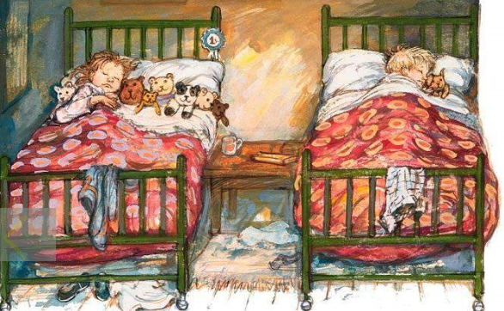

Write four sentences to describe Dave and Bella’s bedroom.
Here are some possible sentence starters…
Dave and Bella share
Their beds are
Dave has
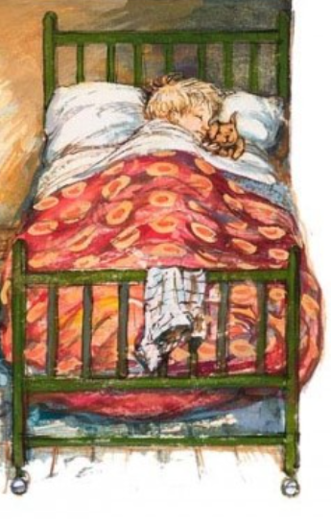
Bella has
They are
Stepping Stone Activity:
Write two sentences to describe Dave in his bed.
Dave is
He is cuddling

