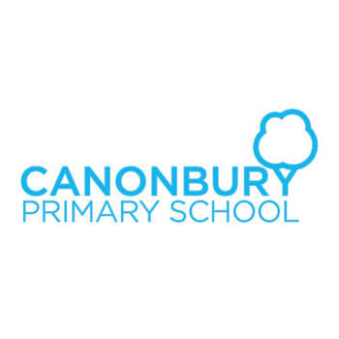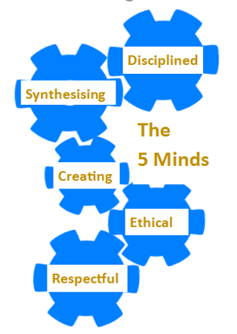

**Year 1 Curriculum Overview**

**Year 1**

**Curriculum Information**

**Autumn 2019**

**Our Canonbury Curriculum -5 Minds for the Future**Our curriculum will enable our children to: acquire substantial knowledge and skills that they remember and can use in the future; make sense of information and communicate their learning to others; ask questions and take flight with ideas to take their learning further; reflect on and exemplify what it is to be a good citizen

Show understanding and appreciation for others who are different to themselves

**Science**

In ourtopic **‘Animals including Humans’** we will

* sort animals into groups: land, air, sea
* label the parts of the body and name the five senses
* identify, name, draw and label the basic parts of the human body
* say which part of the body is associated with each sense
* name and describe the job of some of the organs inside the body.
* 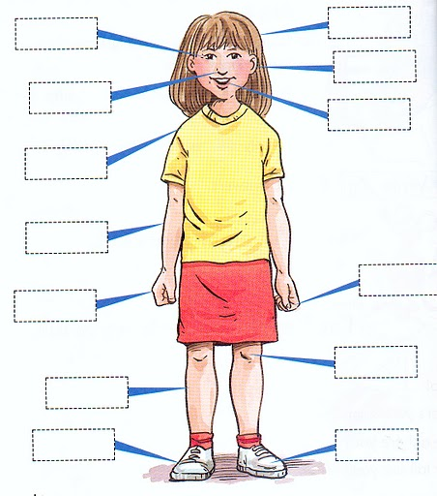

**Maths**

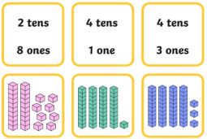We will be learning:

* **Number:** Place value
* **Number:** Mental Addition and subtraction
* **Geometry:** Position and Direction

We will develop our understanding of new mathematical skills using the concrete, pictorial and abstract approach.

**English**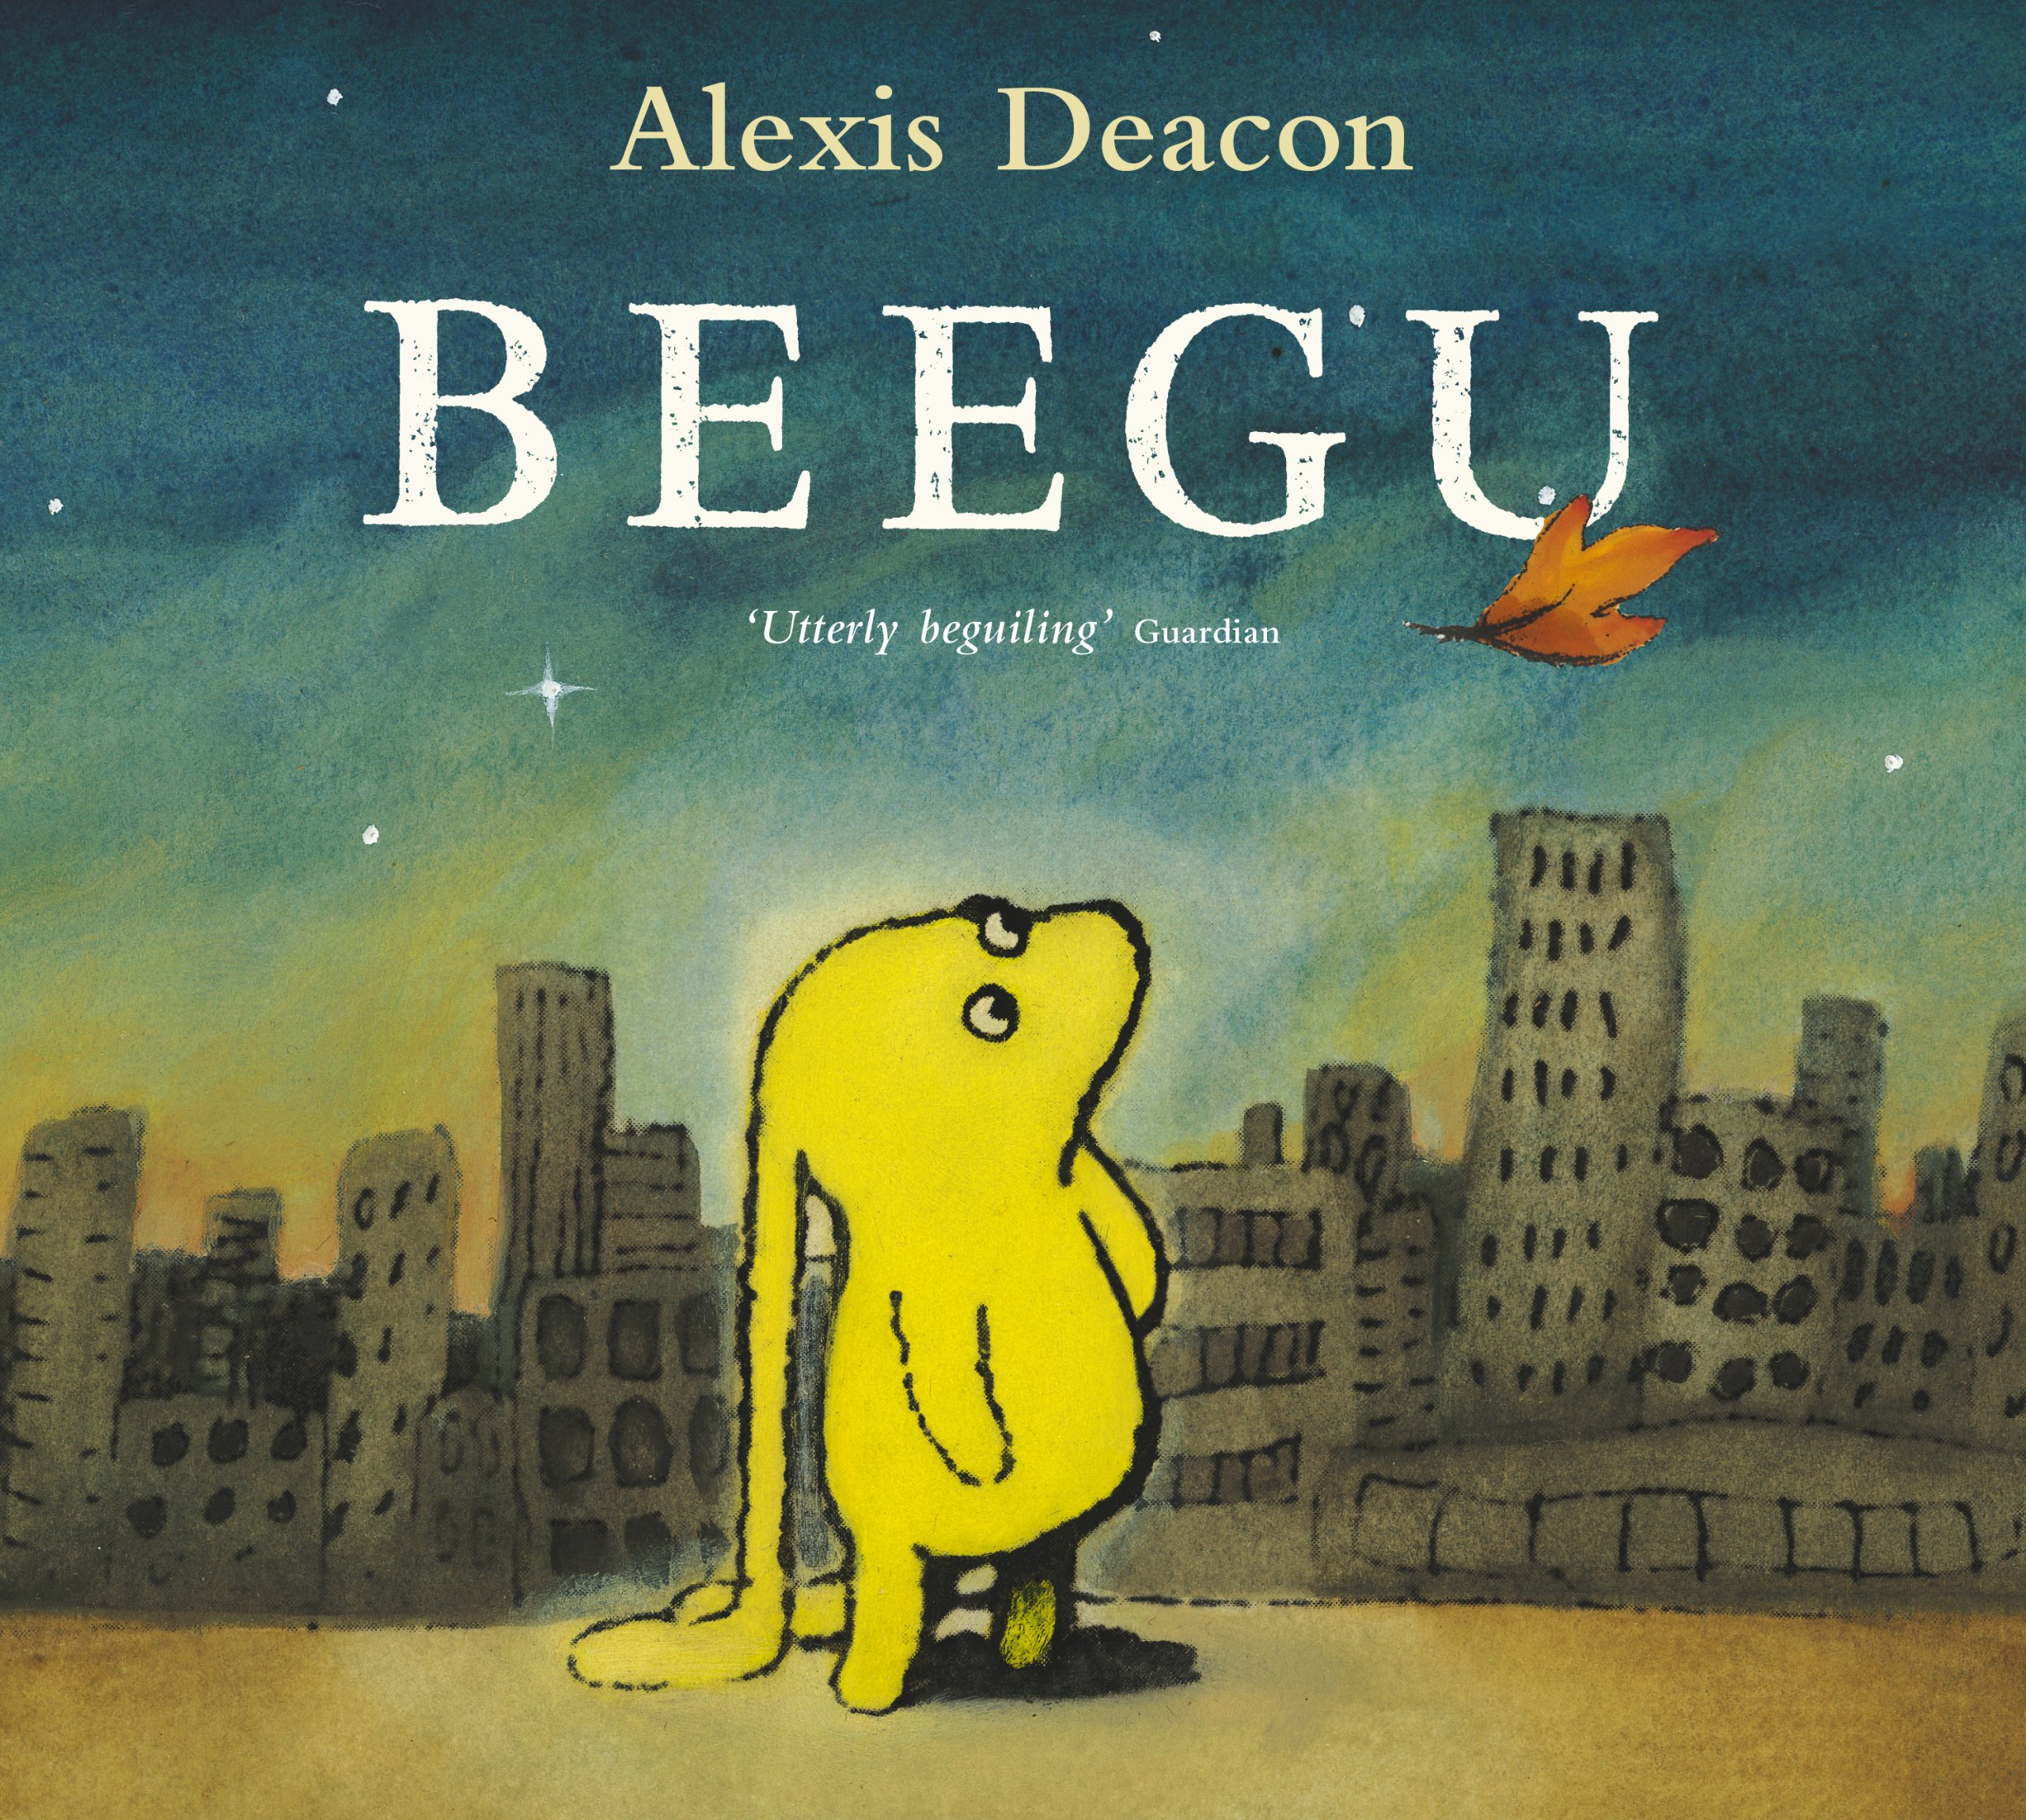 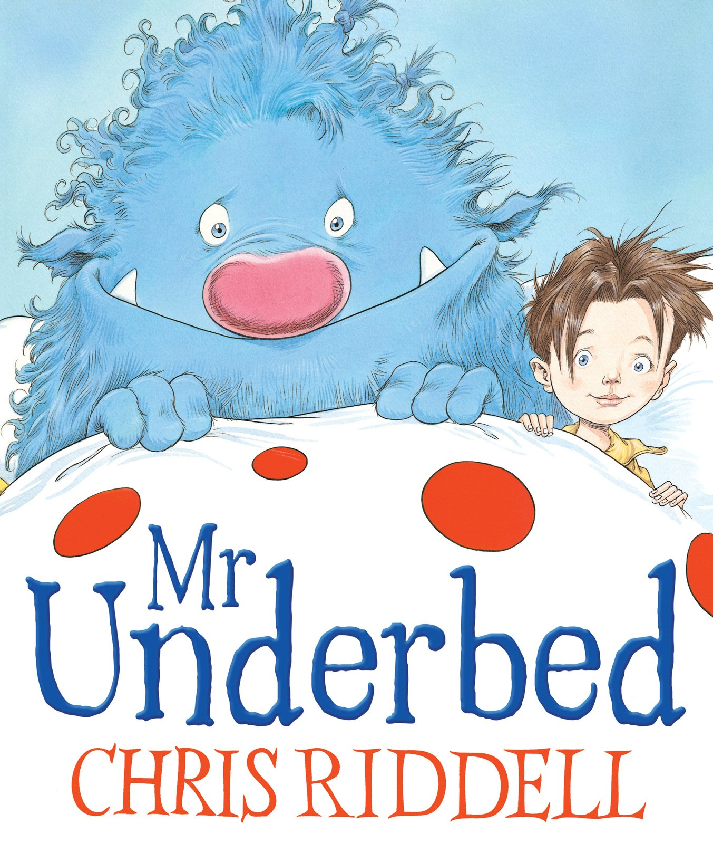The term begins with the book **‘Beegu,’** which is about an alien who makes her way to Earth.

We will then read **‘The Nutcracker’, ’Mr Underbed’** and **‘The Jolly Christmas Postman’**

Our final writing outcomes will include:

* **Narrative**
* **Instructions**
* **Traditional tales.**

**Topic**

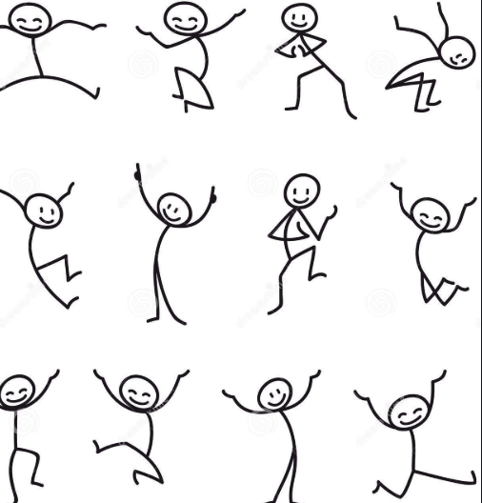  
We will begin by learning about ourselves in our topic **‘Me, Myself and I’**. We will:

* ask questions about ourselves
* learn about changes within our living memory
* learn about our families and where our families come from
* learn about where we live
* think about the future and growing up

-

learn about being healthy: What things make us healthy? We are going to find out because we want to do everything we can to stay healthy. Next, we will look at baby photos – Guess the baby. Talk about the features which have changed.

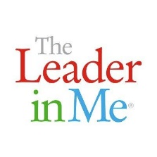

**Computing**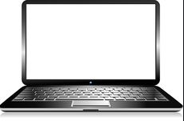

* Logging on
* Self portraits (2Publish)

**PSHE**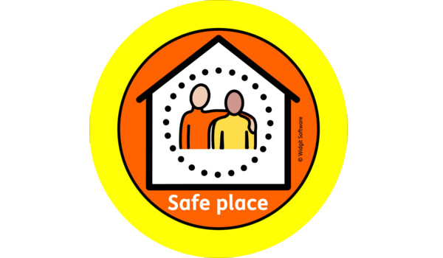

Theme: **Looking after myself**

* About germs and the importance of personal hygiene
* About people who help us to stay healthy and well.
* Leader in Me: 7 Habits of effective people

**Spanish**



Songs – Singing number and greeting songs.

**Music**

* Sing songs and rhymes
* Listen to live music (concert)
* 

**Key Dates**

**Trip to the local church**

**Date TBC**

**Year 1 Christmas Play 12th December 2019**

**Art**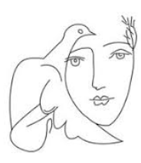Finger painting names.  
Pablo Picasso – work of artist and abstract self portraits

**Religious Studies**



Question:

Who is a Christian and what do they believe?  
  
We will:  
Describe simply some Christian beliefs about God

Describe simply some Christian beliefs about Jesus

Retell a story that shows what Christians believe about God

**Physical Education**

* Multi-skills with Team Kick Start
* Movement games with class teacher.
* Outdoor PE: Monday
* Indoor PE: Tuesday

