Canonbury DT Overview
Year Group | Autumn 1 | Autumn 2 | Spring 1 | Spring 2 | Summer 1 | Summer 2
 | Our City |  | Our Country |  | Our World
EYFS | Coming To Canonbury  Joining skills: All About Me books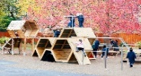 |  | Celebrating our country Mechanisms: Pop up Easter card  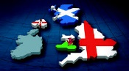 |  | 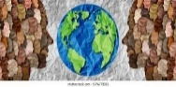  Where in the World Food:  - Fruits salad  - Bread rolls  - Cupcakes
1 | Our Local Area:Local Study of Islington  Textiles: Templates and joining techniques Beegu glove puppet  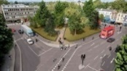 | Canonbury through Time  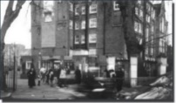 | British Women  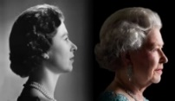  Mechanisms:  Sliders and levers: Making a moving story book – linked to topic using a slider mechanism | 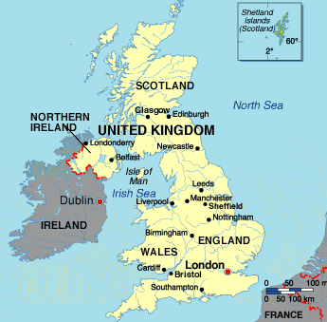  Journey through the UK | 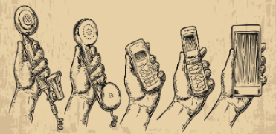  Changes in Communication | 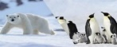  The Poles  Food:  - Tomato salad  - Sandwiches  - Muffins
2 | Great Fire of London  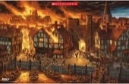  Food:  - Fruit kebabs  - Olive bread  - Samosas | 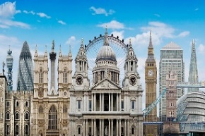  London Landmarks | Activists  Mechanisms: Wheels and Axles Design and create a functional vehicle for an activist | India:  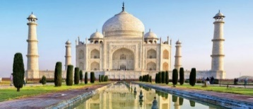 | Seasides Then  Textiles: Templates and joining techniques - Design a puppet for a seaside show  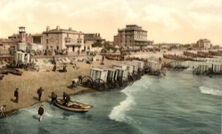 | Seasides now  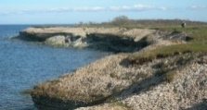
3 | London Transport  Then  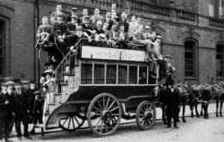 | London Transport Now  Food:  - Pasta salad  - Wrap  - Apple crumble | Stone Age to Iron Age  Textiles: Weaving fabric (using natural dyes) to create a coin purse |  | 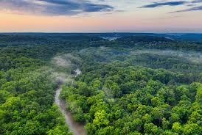  The Rainforest | The Maya  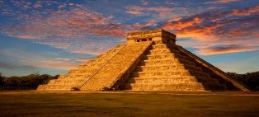  Mechanisms: Structures - Shell structures (design a box for a Mayan worry doll toy)
4 | Roman London  Electrical systems – simple circuits and switches to make a light up Christmas card (Autumn 2)  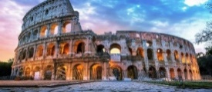 |  | 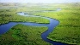  Rivers  Food:  - Pizza  - Guacamole  - Short bread biscuits | Mountains | 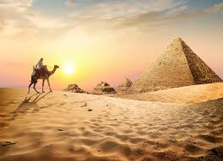  Ancient Egyptians | Sustainable Fashion  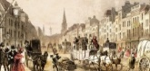  Textiles: 2D shape to 3D product fastenings ‘Fashion’
5 | Diverse London  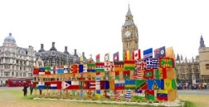 | 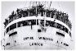  Windrush Generation  Food:  - Caribbean fruit salad  - Falafel  - Welsh cake | Anglo Saxons and the Vikings  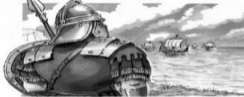  Textiles: Combining different fabric shapes e.g. a mobile phone carrier |  | Walls and Barricades and map skills  Electrical systems: More complex switches and circuits – Design a vehicle alarm or an alarm for a valuable artefact  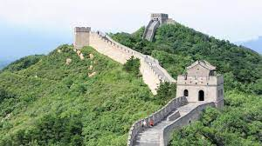
6 | Victorian London  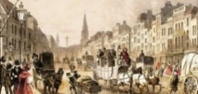  Structures- Frame structures: building bridges linked to the Industrial revolution | London trade  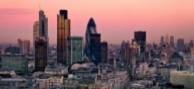 | The Legacy of the Ancient Greeks  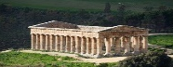  Food:  - Greek salad  - Spaghetti Bolognese  - Scones |  | Natural Disasters  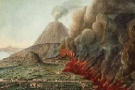  Textiles (Transition project) to make a phone case or tablet case using CAD, with a link to their time in Canonbury School
Key: History Geography Design and Technology: Cooking Mechanisms Textiles

