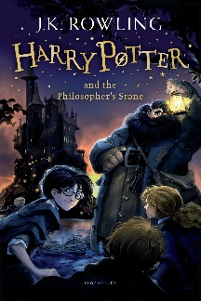
Year 6 Reading
Lesson 2
LO: To read for pleasure.
Success Criteria:
- Read chapter 1 of your guided reading book: Harry Potter and the Philosopher’s Stone.
- Write bullet-pointed notes in your exercise book about the key characters and main events that take place in this chapter.

Example notes
- Mr and Mrs Dursley live at number 4 Privet Drive with their son Dudley
- The Dursleys had everything they wanted
- The family had a secret about the Potter family

