**Year 5 Writing**

**Lesson 2  
LO: To compare different settings**

**Task (with links):**

Watch this video clip: <https://www.literacyshed.com/megacity.html>

Look at the pictures you have been given.

Compare how each of the settings are different. Create a mind map to show the differences.

EXT: Write a short paragraph to compare the differences between each of the settings.

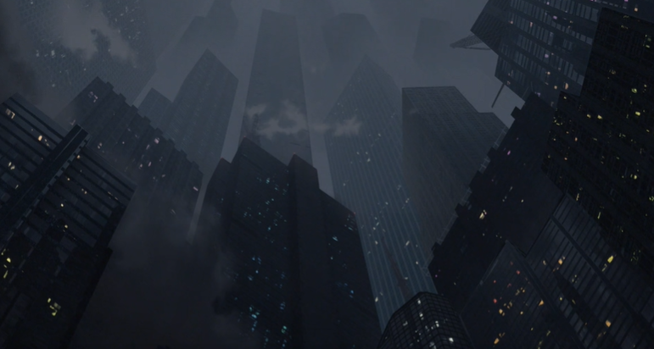  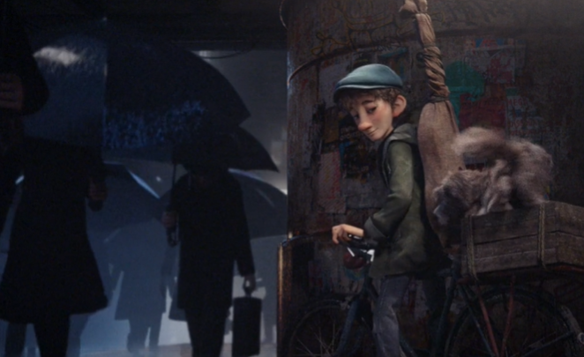

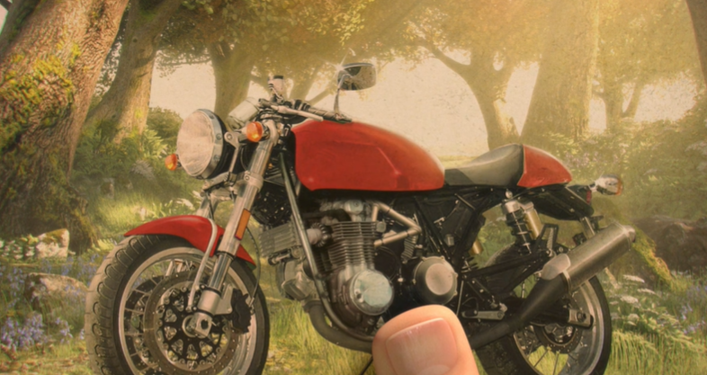 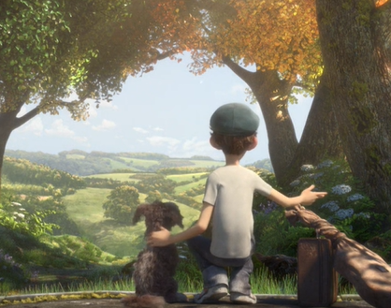 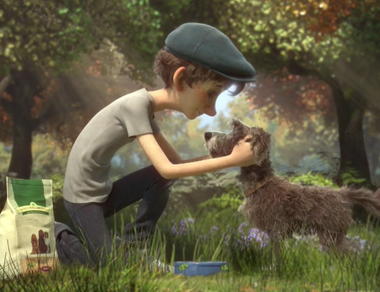

**E.g. Organise your work using this diagram**

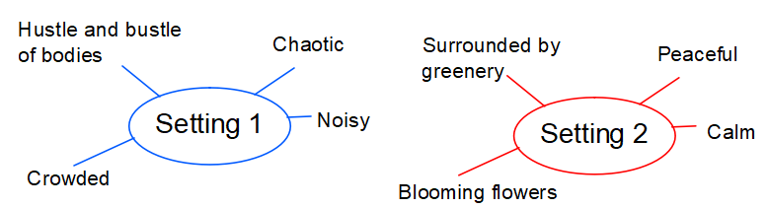

**Year 5 Writing**

**Steppingstone activity**

**Lesson 2  
LO: To compare different settings**

**Task (with links):**

Watch this video clip: <https://www.literacyshed.com/megacity.html>

Look at the pictures you have been given.

Describe each of the different settings; the city and the countryside.

EXT. Beneath each setting spider web write a descriptive sentence about the settings.

 

 

**E.g. Organise yur work like this to help you see the differences**

