Year 6 Maths
Developing activity
Lesson 3
LO: TBAT compare and order negative numbers.
Success Criteria:
- Choose a temperature.
- Check where it is on the interactive thermometer.
- Compare the 2 temperatures.
- Place a greater than or less than symbol between the two temperatures.
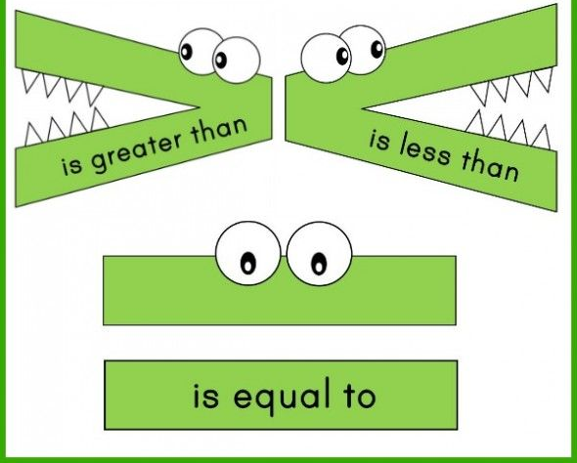
Model
Take a look at the interactive thermometer and use it to answer the following questions…
https://mathsframe.co.uk/en/resources/resource/89/itp-thermometer

Now you try…
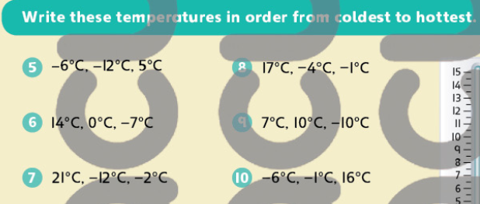
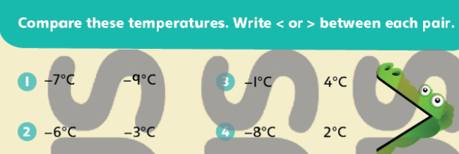

Year 6 Maths
Expected/ Greater depth activity
Lesson 3
LO: TBAT apply the use of negative numbers in a range of contexts.
Task:
You are going apply your knowledge of negative numbers to solve several problems.
Success Criteria:
- Identify the starting number in the sum.
- Identify the operation needed to solve the sum.
- Calculate.
- Use the inverse to check your answer.

Recap:
Take a look at the interactive thermometer and use it to answer the following questions…
https://mathsframe.co.uk/en/resources/resource/89/itp-thermometer
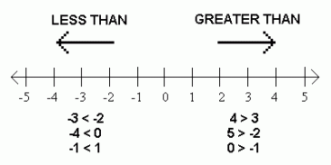
Year 6 Maths
Main activity
Complete at least 2 columns, more if you can!
Task 1 | Task 2 | Task 3 | Task 4
Practice  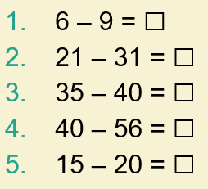  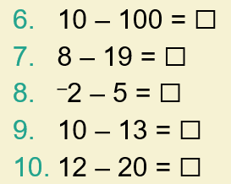  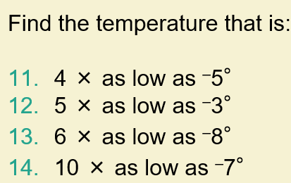 | Arithmetic  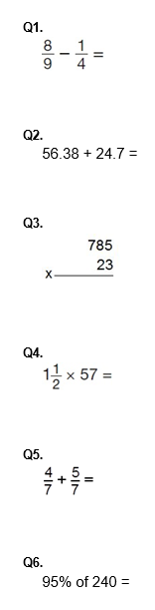 | Reasoning  Explain your answers.  Task 1  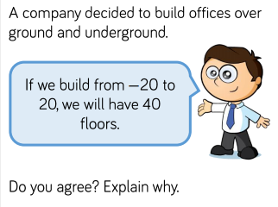  Task 2  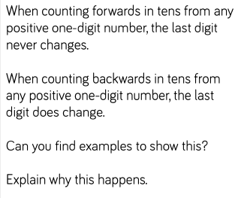 | Problem solving  Task 1  Here are the temperatures in four cities at midnight and at midday.  Temperature  City At midnight At midday  Paris −4°C −2°C  Oslo −13°C −7°C  Rome 3°C 10°C  Warsaw −6°C 2°C  At midnight, how many degrees colder was Paris than Rome?  Which city was 6 degrees colder at midnight than at midday?  Task 2  Here are two thermometers. They show two different temperatures.  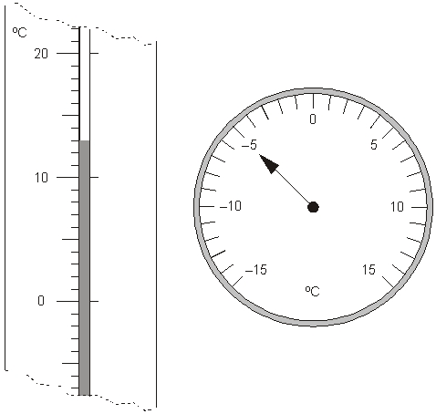  What is the difference between the two temperatures?

