Task 1 | Task 2 | Task 3 | Task 4
Developing Task Answers  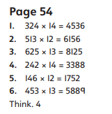  Practice  Have a go at these subtractions. Use the written method:  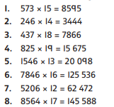 | Arithmetic  Have a go at these additions.  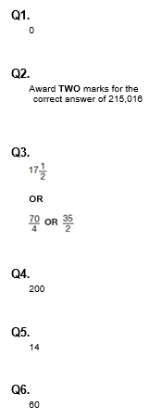 | Reasoning  Explain your answers.  Task 1  Award THREE marks for the correct answer of 7,174  If the answer is incorrect, award TWO marks for:  • evidence of an appropriate complete method which contains no more than ONE arithmetic error, e.g.  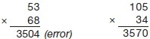  Task 2  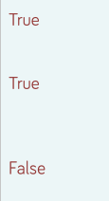 | Problem solving  Task 1  Award ONE mark for three correct answers, as shown:  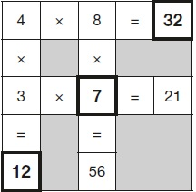  Task 2  