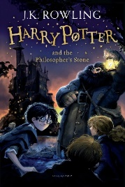
Year 6 Reading
Lesson 3
LO: To retrieve and record information from a text.
Success Criteria:
- Read each question and identify the key words.
- Skim and scan through the chapter to find the answer to each question, based on the page number given.
- Write your answer in short form (not full sentences).

Questions
- What did Mr Dursley work as? (Page 1)
- On which day did the story begin? (Page 2)
- What did Mr Dursley think he saw the cat doing? (Page 3)
- What made Dursley’s morning feel normal? (Page 4)
- Who did Mr Dursley bump into when he left work to go back home? (Page 5)
- What kind of day did Mrs Dursley have? (Page 6)
- Where was Albus Dumbledore seen? (Page 9)
- What was odd about Dumbledore’s watch? (Page 13)
- Where did Hagrid lay Harry (Page 17)
- What were Dumbledore’s parting words to Harry? (Page 18)

