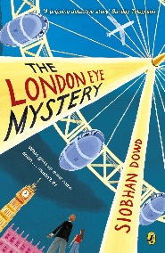
Year 5 Reading
Lesson 3
LO: To retrieve and record information.
Activity 1: Answer the following 5 questions based on chapter 1.
Success Criteria:
- Read the question carefully
- Underline the key words in the question
- Find the answer in the text
- Write your answer

- How many capsules are there on the London Eye? (Page 1)
- What river could be seen from the London Eye (Page 1)
- Who gave Salim a free ticket to get onto the London Eye? (Page 2)
- What time was Salim due to come down from the London Eye? (Page 3)
- How long did Salim ride the London Eye for? (Page 4)
Activity 2: Use the story, to answer true or false to each statement below.
Success Criteria:
- Read each statement
- Reread the text to find if the statement is true or false
- Write ‘true’ or ‘false’ next to each statement

- The capsules are made from strong plastic.
- According to the narrator, the London eye looked like a big giant wheel.
- Salim boarded his capsule on 24th June.
- The passengers left the capsule in groups of 10.
- When his capsule landed, Salim was stood smiling inside.

