Year 5 Writing
Lesson 3
LO: To create opening sentences
In the previous lessons you have watched a video link and created a plan for a narrative about Alma.
Task:
Continuing with your narrative, plan a range of sentence openers that you can use for each paragraph of Alma’s story. A minimum of 2 sentence openers per paragraph.
Eg.
With thoughts of nothing but snow and fun racing through her mind,
Noticing a chalk-board,

Organise your writing in rows
Main Idea for the Paragraph
1
2
3
4
5
6

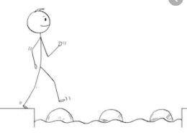
Year 5 Writing
Steppingstone activity
Lesson 3
E.g. Peeking through the window,
Without giving it much thought,
In the distance,

Main Idea for the Paragraph
Eg.

1
2
3
4
5
6
Task:
Continuing with your narrative, plan a range of sentence openers that you can use for each paragraph of Alma’s story. A minimum of 2 per paragraphs for each.
Eg.
With thoughts of nothing but snow and fun racing through her mind,
Noticing a chalk-board,

Use some of these key words to help you.
