Year 5 Maths
Steppingstone activity
Lesson 4
LO: To divide 4 digit by 1 digit numbers
Success Criteria:
- Draw the ‘Bus stop’
- Start by dividing the thousands by the divisor and carrying any remainders
- Now divide the 100’s
- Now divide the 10’s
- Now divide the 1’s.

Model
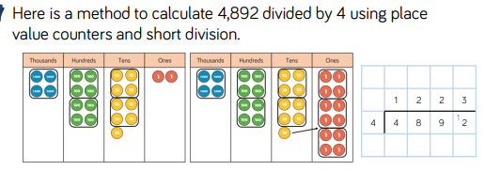

Now you try…
6,610 ÷ 5 2,472 ÷ 3 9,360 ÷ 4 6,945 ÷ 5
1,322 824 2,340 1,389

Year 5 Maths
Lesson 4
LO: To divide 4 digit by 1 digit numbers
Task:
You are going to continue practising multiplying!
Success Criteria:
- Draw the ‘Bus stop’
- Start by dividing the thousands by the divisor and carrying any remainders
- Now divide the 100’s
- Now divide the 10’s
- Now divide the 1’s.

Model:

Make sure all your answers are in the correct columns!!!
Year 5 Maths Lesson 4
LO: To divide 4 digit by 1 digit numbers
Main activity
Complete at least 2 columns, more if you can!
Task 1 | Task 2 | Task 3 | Task 4
Practice  Have a go at these Divisions.  145 ÷ 5 = 29  168 ÷ 3 =56  202 ÷ 2 =101  295 ÷ 5 =59  336 ÷ 4 =84  336 ÷ 6 =56 | Practice  Have a go at these divisions that may have remainders.  134 ÷ 3 =44r2  678 ÷ 7 = 96r6  309 ÷ 4 =77r1  230 ÷ 6 =38r2  467 ÷ 5 =93r2  562 ÷ 8 =70r2 | Reasoning  Explain your answers.  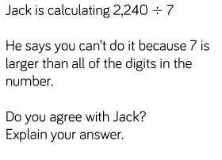  No the answer is 320  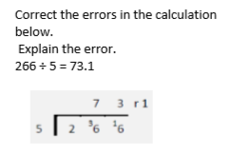  He has carried 3 instead of 2 in the first part – 53r1 | Problem solving  194 divided by 9 = 21r5  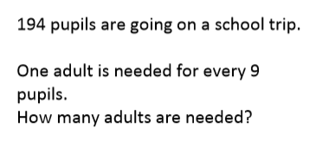  22 adults needed  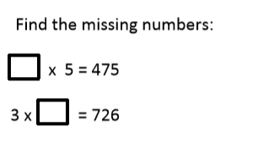  95  242

