Year 6 Maths
Developing activity
Lesson 4
LO: TBAT divide numbers using short division.
Success Criteria:
- Write out the division using the bust stop methd.
- Work out how many of the divisor go into each digit of the number.
- Remember to carry the remainder over.
- Check your answer.
Model
Short division
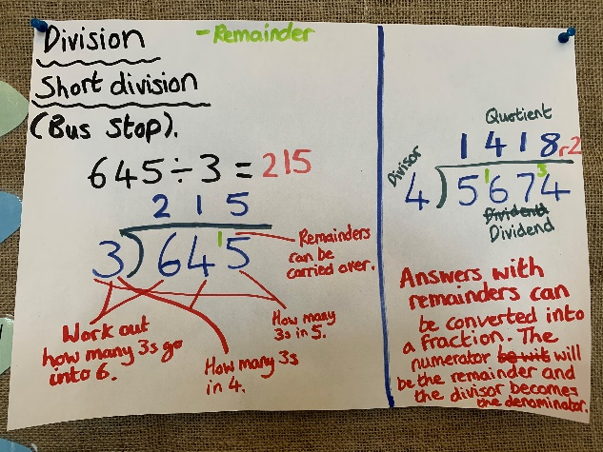
Now you try…
Then, create 3 of your own!
Year 6 Maths
Expected/ Greater depth activity
Lesson 4
LO: TBAT use division in a range of contexts.
Task:
You are going apply your knowledge of division to solve several maths problems.
Success Criteria:
- For written methods ensure your layout is correct.
- When dividing with decimals ensure your answers also have decimals.
- When dividing fractions, divide the numerator and keep the denominator the same.

Recap:
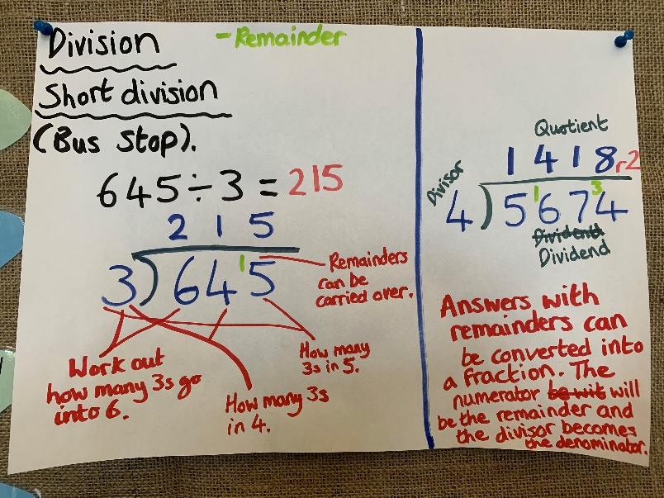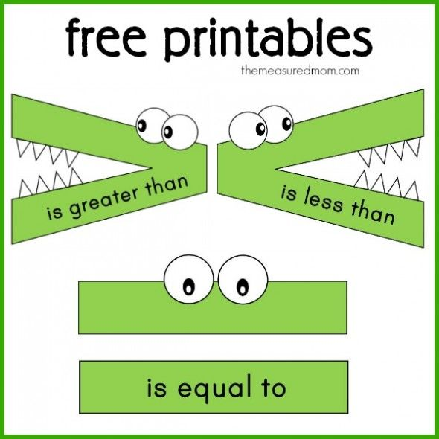
Year 6 Maths
Main activity
Complete at least 2 columns, more if you can!
Task 1 | Task 2 | Task 3 | Task 4
Practice  Have a go at these divisions. Convert your remainders into fractions:  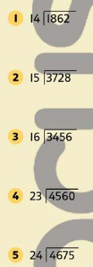 | Arithmetic  Have a go at these subtractions.  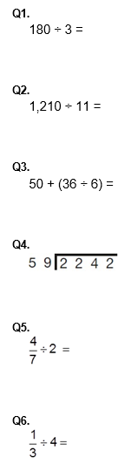 | Reasoning  Explain your answers.  Task 1  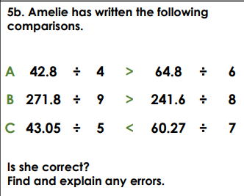  Task 2  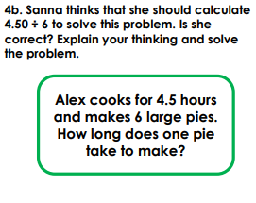 | Problem solving  Task 1  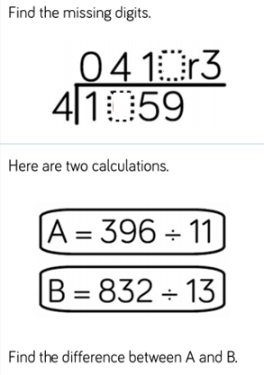  Task 2  