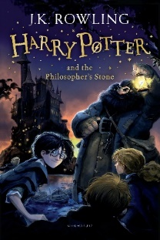
Year 6 Reading
Lesson 4
LO: To retrieve information from a text to draw a character.

Success Criteria:
- Read the paragraph beginning, ‘Nothing like this man had ever been seen on Privet drive’ on page 9. (Extract below)
- Use the information in this paragraph to draw a picture of Albus Dumbledore.
- Label your picture with quotes from the text. E.g. He was tall, thin and very old.
Nothing like this man had ever been seen in Privet Drive. He was tall, thin and very old, judging by the silver of his hair and beard, which were both long enough to tuck into his belt. He was wearing long robes, a purple cloak which swept the ground and high-heeled, buckled boots. His blue eyes were light, bright and sparkling behind half-moon spectacles and his nose was very long and crooked, as though it had been broken at least twice. This man’s name was Albus Dumbledore.

