Year 5 Maths
Steppingstone activity
Lesson 4
LO: To divide 4 digit by 1 digit numbers
Success Criteria:
- Draw the ‘Bus stop’
- Start by dividing the thousands by the divisor and carrying any remainders
- Now divide the 100’s
- Now divide the 10’s
- Now divide the 1’s.

Model
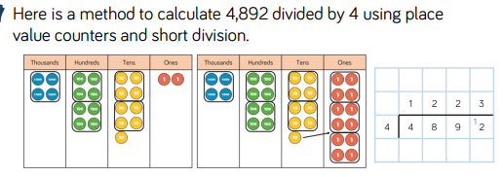

Now you try…
6,610 ÷ 5 2,472 ÷ 3 9,360 ÷ 4 6,945 ÷ 5

Year 5 Maths
Lesson 4
LO: To divide 4 digit by 1 digit numbers
Task:
You are going to continue practising dividing!
Success Criteria:
- Draw the ‘Bus stop’
- Start by dividing the thousands by the divisor and carrying any remainders
- Now divide the 100’s
- Now divide the 10’s
- Now divide the 1’s.

Model:

Make sure all your answers are in the correct columns!!!
Year 5 Maths Lesson 4
LO: To divide 4 digit by 1 digit numbers
Main activity
Complete at least 2 columns, more if you can!
Task 1 | Task 2 | Task 3 | Task 4
Practice  Have a go at these division questions.  145 ÷ 5 =  168 ÷ 3 =  202 ÷ 2 =  295 ÷ 5 =  336 ÷ 4 =  336 ÷ 6 = | Practice  Have a go at these divisions that may have remainders.  134 ÷ 3 =  678 ÷ 7 =  309 ÷ 4 =  230 ÷ 6 =  467 ÷ 5 =  562 ÷ 8 = | Reasoning  Explain your answers.  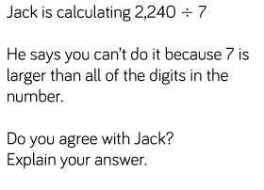  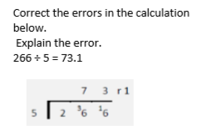 | Problem solving  