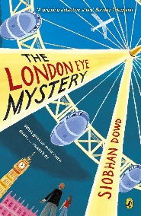
Year 5 Reading
Lesson 4
LO: To understand unfamiliar words.
Activity: Match the words from the text to its synonym.
Success Criteria:
- Find each word in the text.
- Read the whole sentence that the word is written in.
- Use your understanding of the sentence to match the word to its synonym.

Words from the text
Sealed (Page 1)
Oesophagus (Page 2)
Boarded (Page 3)
Orbit (Page 3)
Figure out (Page 4)
Synonyms
Got on
Discover
Throat
Circle
Closed

Activity 2: Write the words in red into your own made up sentence.
Example: Yesterday morning, I boarded the Victoria line train from Highbury and Islington and made my way to Oxford Circus.
Year 5 Reading
Lesson 4
LO: To understand unfamiliar words.
Activity: Match the words from the text to its synonym.
Success Criteria:
- Find each word in the text
- Read the whole sentence that the word is written in
- Use your understanding of the sentence to match the word to its synonym

Words from the text
Sealed (Page 1)
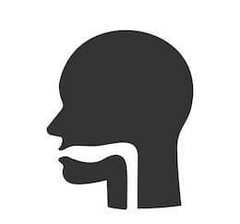
Oesophagus (Page 2)
Boarded (Page 3)
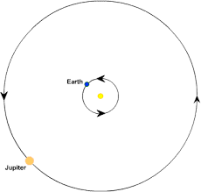
Orbit (Page 3)
Figure out (Page 4)

Synonyms
Got on
Discover
Throat
Circle
Closed

Activity 2: Write the words from the text into your own made up sentence.
Example: Yesterday morning, I boarded the Victoria line train from Highbury and Islington and made my way to Oxford Circus.

