Year 6 Maths
Developing activity
Week 2, Lesson 4
LO: TBAT read and plot coordinates.
Success Criteria:
- Find the number on the x axis (horizontal line)
- Then find the number on the y axis (vertical line)
- Ensure both numbers are written in brackets with a comma separating them e.g. (4, 6).
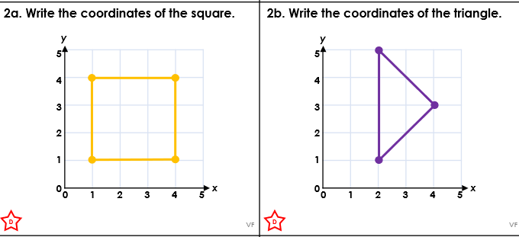
Recap
Please find the coordinates rap on lgfl and watch to recap how to plot points.
http://mathsraps.lgfl.org.uk/
Now you try…
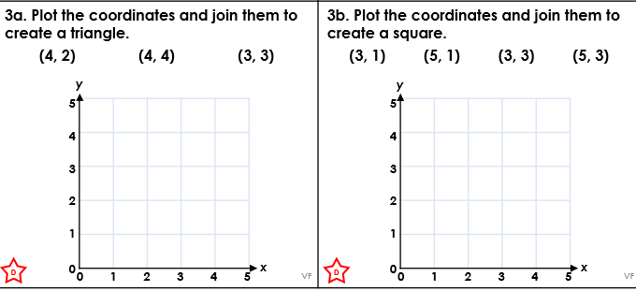
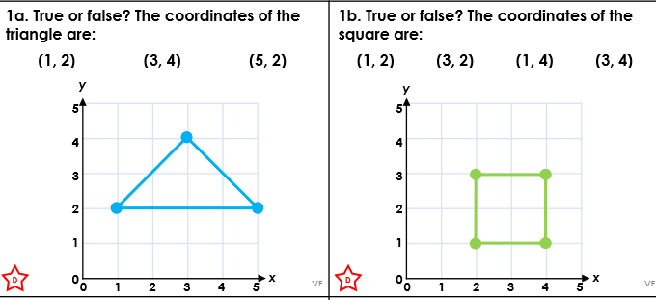
EXT: If you do not have the board game at home, why not try playing battleships online.
https://www.battleshiponline.org/

Year 6 Maths
Expected/ Greater depth activity
Lesson 4
LO: TBAT read and plot coordinates, on grids with up to 4 quadrants.
Task:
You are going apply your knowledge of coordinates to solve several problems.
Success Criteria:
- Find the first part of the coordinate on the x axis (horizontal line)
- Identify the second part of the coordinate on the y axis (vertical line)
- Use the coordinates to identify shapes.
Recap:
Please find the coordinates rap on lgfl and watch to recap how to plot points.
http://mathsraps.lgfl.org.uk/
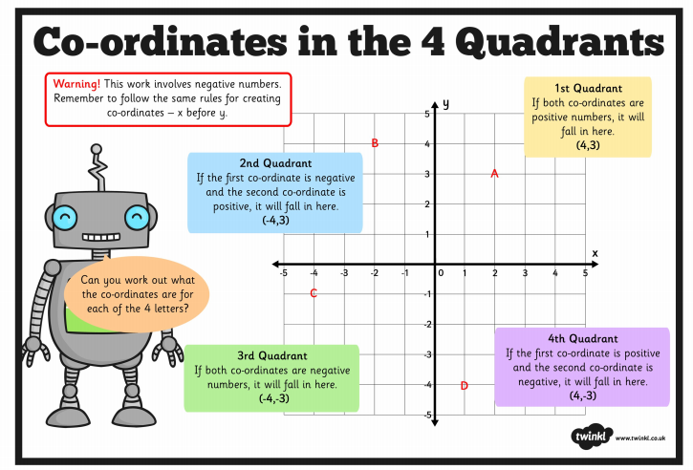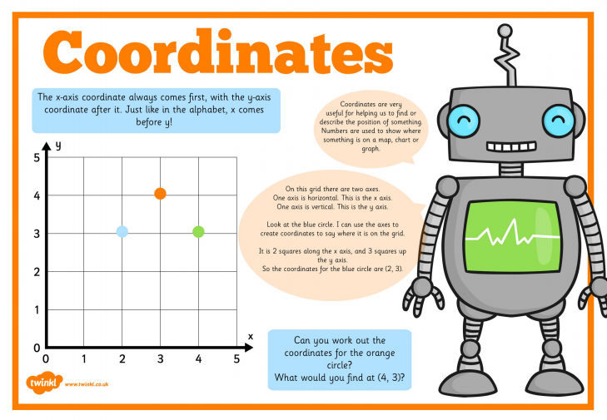
Year 6 Maths
Main activity
Complete at least 2 columns, more if you can!
Task 1 | Task 2 | Task 3 | Task 4
Practice  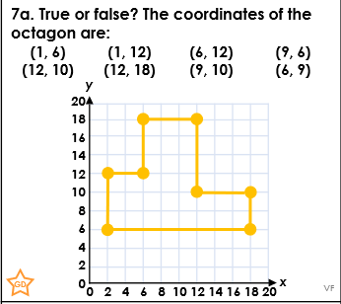  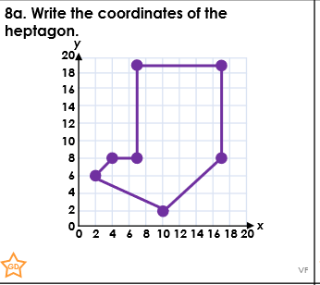  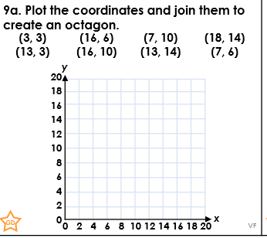 | Arithmetic  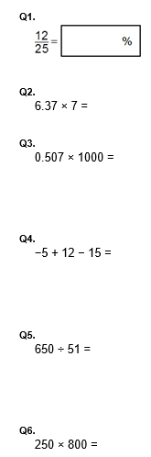 | Reasoning  Explain your answers.  Task 1  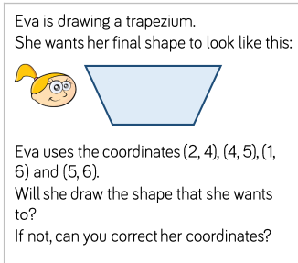Task 2  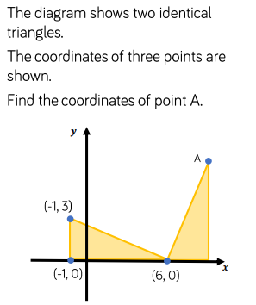 | Problem solving  Task 1  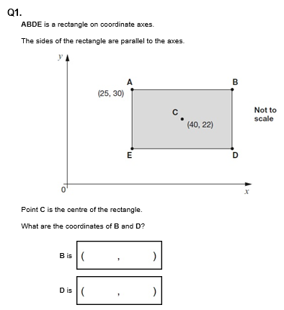  Task 2  