Year 6 Maths
Developing activity
Lesson 1
LO: TBAT add 5-digit numbers.
Success Criteria:
- Write out the addition (one number under the other) with a totals line.
- Start adding the digits from the right hand side.
- Do not remember to carry if the total is more then 1- digit.
- Check your answer.

Recap

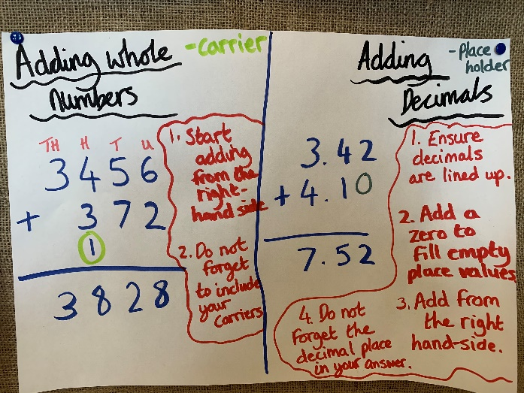
Now you try…
35,284 + 12,461 = 53,164 + 31,263 = 28,341 + 42,025 = 51,963 + 26,320 =?
25,674 + 35,251 = 19,875 + 42,312 =
Then, create 3 of your own!
Year 6 Maths
Expected/ Greater depth activity
Lesson 1
LO: TBAT use addition in a range of arithmetic contexts.
Task:
You are going apply your knowledge of addition to solve several arithmetic problems.
Success Criteria:
- For written methods ensure your place value columns are lined up correctly.
- When adding decimals ensure decimals are in line.
- Find the lowest common multiple for adding fractions.
- Using the inverse can help check your answers.

Recap:
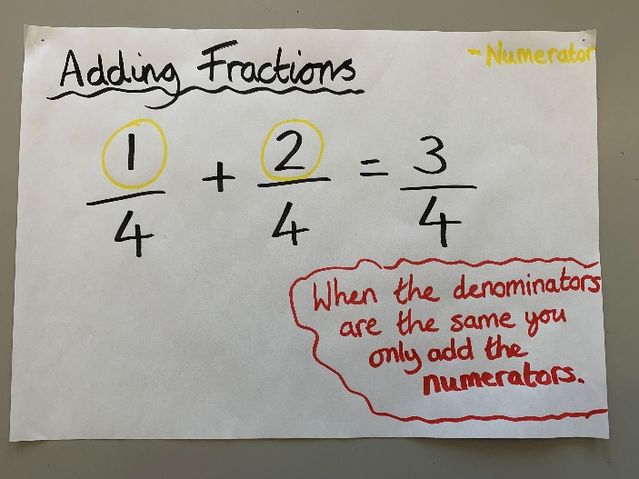 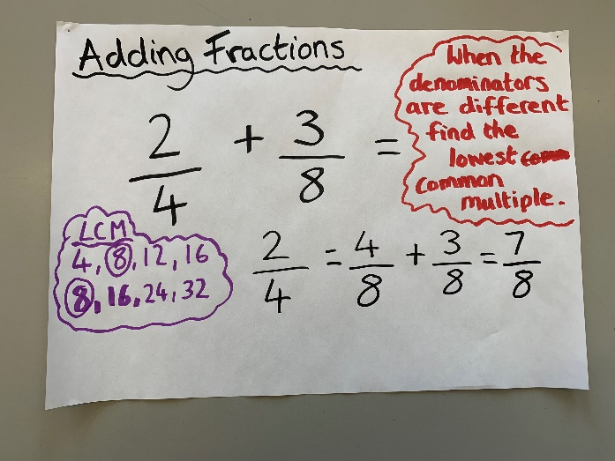
Year 6 Maths
Main activity
Complete at least 2 columns, more if you can!
Task 1 | Task 2 | Task 3 | Task 4
Practice  Have a go at these additions. Use the written method:  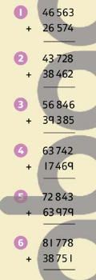 | Arithmetic  Have a go at these additions.  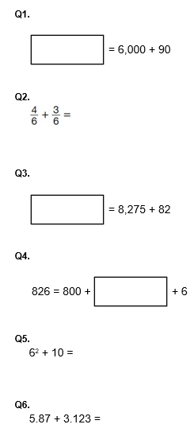 | Reasoning  Explain your answers.  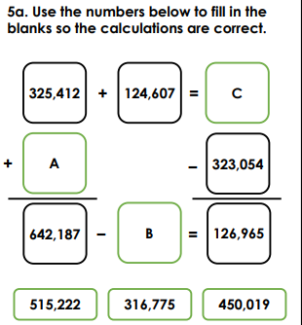  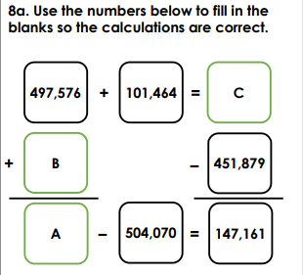 | Problem solving  