Year 6 Maths
Developing activity
Lesson 1
LO: TBAT identify multiples.
Success Criteria:
- TBAT apply division to find multiples of numbers.

Model
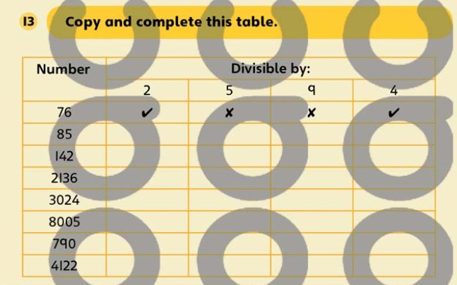
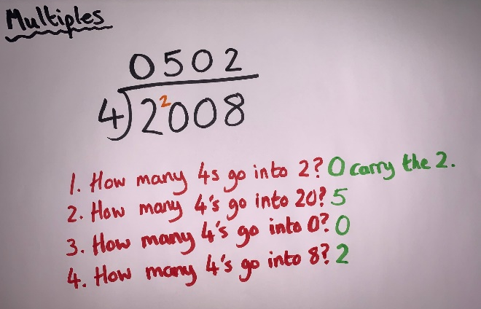
Now you try…
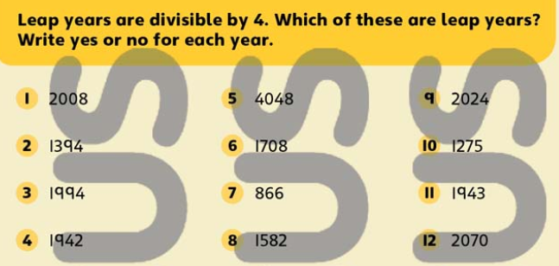Complete 6.

Year 6 Maths
Expected/ Greater depth activity
Lesson 1
LO: TBAT find multiples of numbers.
Task:
You are going apply your knowledge of multiples to solve several problems.
Success Criteria:
- Choose the two factors.
- Create a Venn diagram.
- Start to fill in the diagram with multiples.
- Write the first 3 common multiples, circling the lowest common multiple.
Recap:
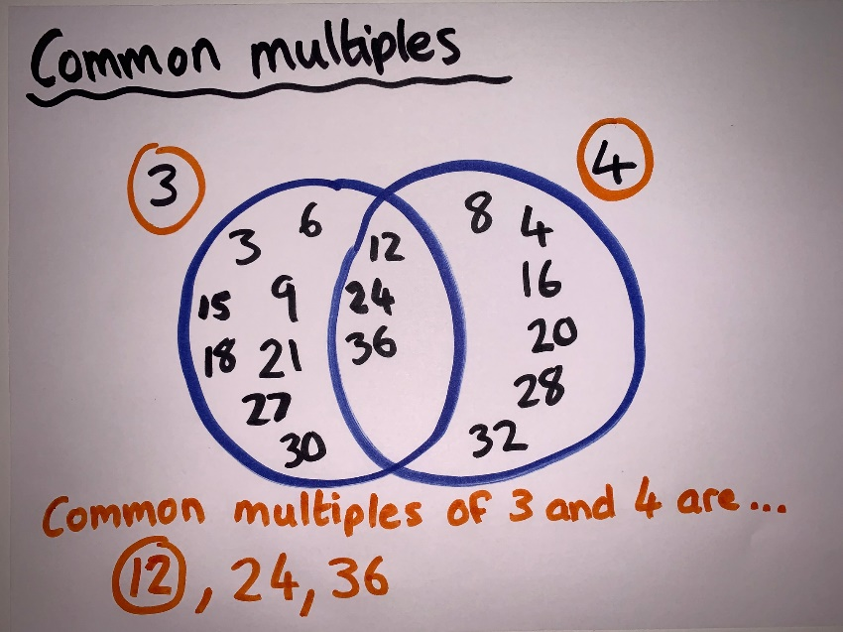
Year 6 Maths
Main activity
Complete at least 2 columns, more if you can!
Task 1 | Task 2 | Task 4
Practice  Have a go at finding the factors.  Write three common multiples for each set of numbers. Include the smallest common multiple and ring it.  - 3, 4  - 2, 5  - 5, 3  - 8, 12  - 4, 10  - 2, 5 and 6  - 3, 4 and 5. | Reasoning  Explain your answers.  Task 1  Draw rings around all the multiples of 5  45 20 54  17 40  Task 2  Write the missing numbers in the sequence.  Task 3  Here is part of a number line.  Write the correct number in the box.  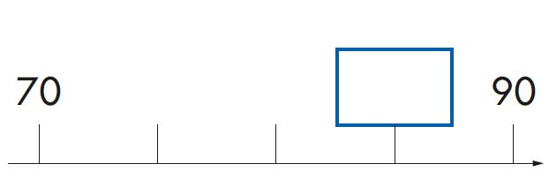 | Problem solving  Task 1  Look at these four fruits.  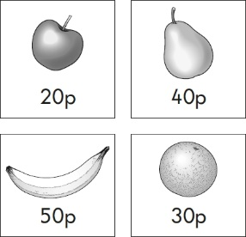  Kemi buys three different fruits.  She spends exactly £1  Tick the three fruits that she buys.  Task 2  Each pair of cards has a total of 70  Write numbers to complete the pairs.  One is done for you.  