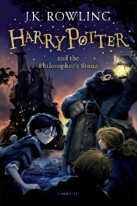
Year 6 Reading
Lesson 1
LO: To make inferences from an image about a story.
- Have a close look at the 3 front covers of Harry Potter and the Philosopher’s Stone book and film cover.
- Based on what you can see on the 3 front covers, infer information about the following:

-Genre: What type of story do you think this is and why?

-Characters: Who do you think are the main characters and what can you infer about them from the front covers?

-Setting: Where do you think the story is set and why?

-Prediction: What do you think will happen in the story based on the front covers?

Remember to write your inferences based on what you see rather than what you may already know about the text.
Success Criteria:
Example 1:
Characters: I think the main character of the story is Harry Potter as that is the title of the book and it is written in bold, capital letters on the front of both book covers.
Example 2:
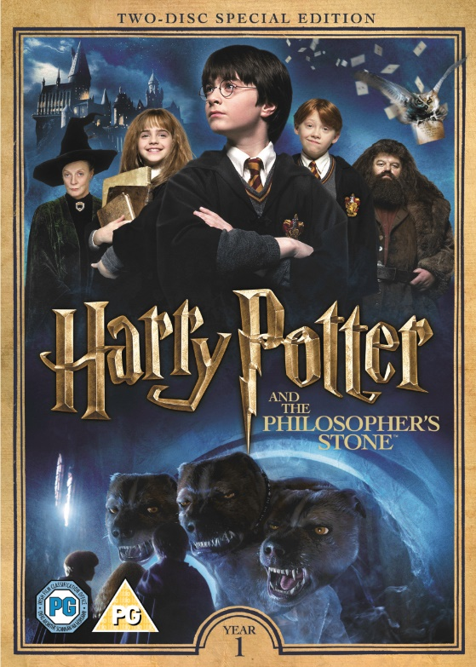
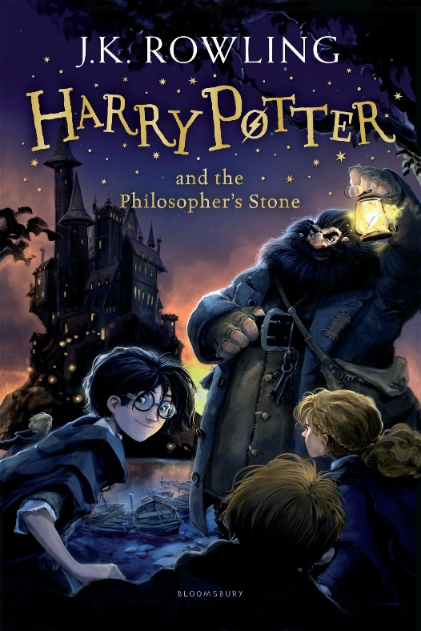
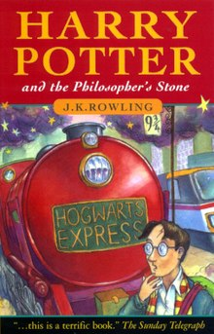
Genre: The genre of this story might be a mystery because in the first front cover Harry has a puzzled expression on his face suggesting that he is will need to work something out in the story that he does not yet know the answer to.

