Year 5 Writing
Lesson 1
LO: To create descriptive sentences
Task (with links):
Watch this video clip: https://www.literacyshed.com/megacity.html
Look at the pictures you have been given.
Create sentences for each one, using a subordinate clause.
The sentences should all be about the images below.
EXT: Extend your sentences with a subordinating conjunction.

Word bank:
Fronted Adverbials | Adjectives | Nouns | Verbs
By the train station,  As fast as he could,  During the cold months,  Eventually at home, | harsh days  weary nights  looming skyscrapers  cold, dark world  rush of city life | Busker - Jack  Dog - Harry  guitar  countryside  motorbike | shivered  gathered  dreamed  ride  played
E.g. Eventually at home, Jack enjoyed the comfort of his bed. Harry, his furry companion, lay beside him.
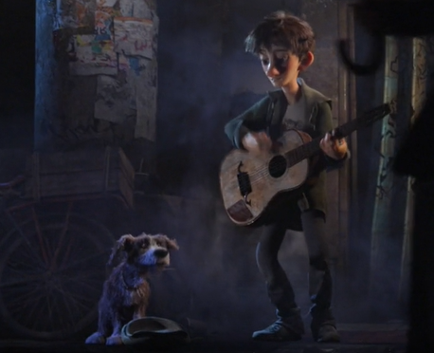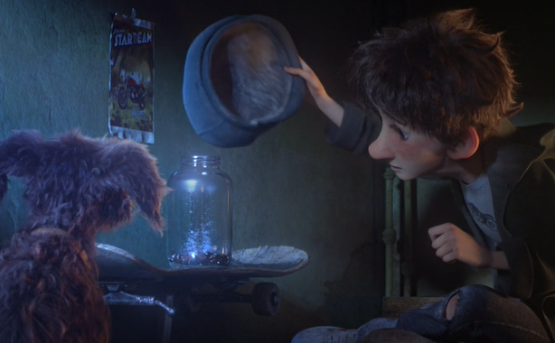
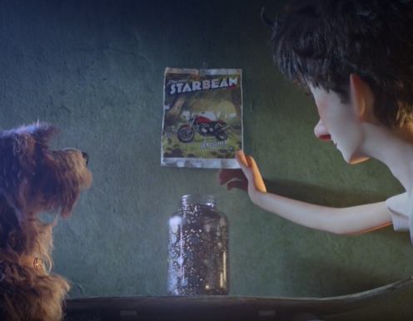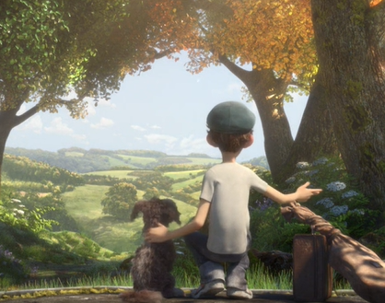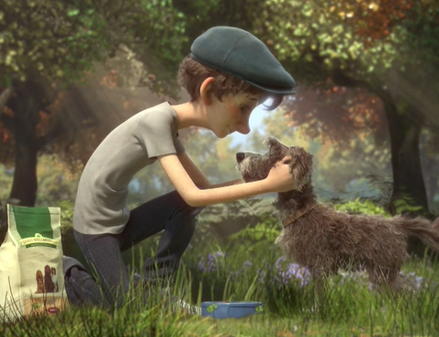

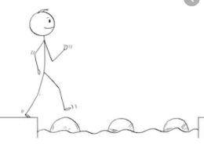
Year 5 Writing
Steppingstone activity
Lesson 1
LO: To create descriptive sentences
Success Criteria:
Task (with links):
Watch this video clip: https://www.literacyshed.com/megacity.html
Look at the pictures you have been given.
Create 2 expanded noun phrases for each one. Use the word bank to help you.
- Look at the picture
- Choose a noun
- Choose 2 adjectives to describe the noun (or come up with your own!)
- Remember your comma!
Word bank:
Fronted Adverbials | Adjectives | Nouns | Verbs
By the train station,  As fast as he could,  During the cold months,  Eventually at home, | cold days  long, weary nights  looming skyscrapers busy world  rush of city life | Busker - Jack  Dog - Harry  guitar  countryside  motorbike | shivered  gathered  dreamed  ride  played
E.g. Eventually at home, Jack enjoyed the comfort of his bed away from the hustle and bustle of the city.

