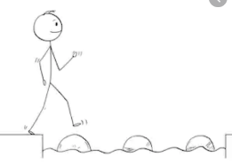
Year 5 Maths
Steppingstone activity
Lesson 1
LO: To multiply 2 digit numbers by 2 digit numbers
Success Criteria:
- Layout your multiplication accurately (brackets in line with answers)
- Multiply the top 2 digit number by the units first
- Multiply the top 2 digit number by the 10’s remembering to add a ‘0’ as a placeholder
- Add the two amounts together to form an answer.
- Layout your multiplication accurately (brackets in line with answers)

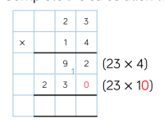
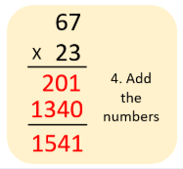
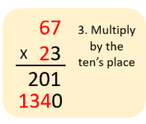
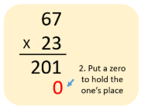
Model
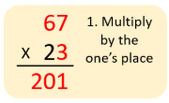
- 2. 3. 4.

Now you try…
45 x 23 = ? 36 x 31 = ? 47 x 23 = ? 65 x 38 =? 52 x 42 = ? 63 x 15 = ?
Then, come up with some of your own!

Year 5 Maths
Lesson 1
LO: To multiply 3-digit numbers by 2-digit numbers
Task:
You are going to practise multiplying!
Success Criteria:
- Layout your multiplication accurately (brackets in line with answers)
- Multiply the top 3 digit number by the units first
- Multiply the top 3 digit number by the 10’s remembering to add a ‘0’ as a placeholder.
- Add the two amounts together to form an answer.
- Layout your multiplication accurately (brackets in line with answers)

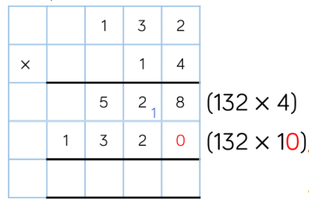
Model:

Make sure all your answers are in the correct columns!!!
Year 5 Maths
Main activity
Complete at least 2 columns, more if you can!
Task 1 | Task 2 | Task 3 | Task 4
Practice  Have a go at these multiplications.  13 x 42  26 x 53  27 x 32  71 x 69  84 x 17  92 x 39 | Practice  Have a go at these multiplications.  134 x 31  231 x 24  235 x 14  230 x 59  453 x 32  562 x 55 | Reasoning  Explain your answers.  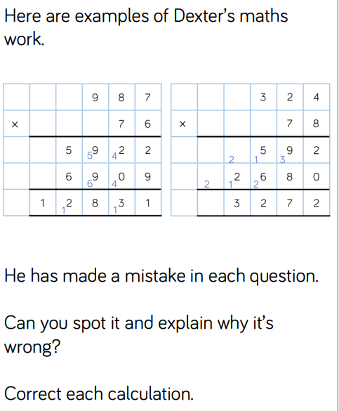 | 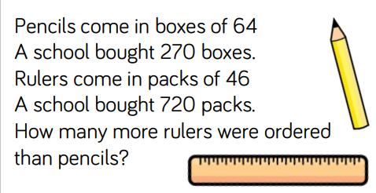  Problem solving  