Year 6 Maths
Developing activity
Lesson 2
LO: TBAT multiply and divide by 10, 100 and 1000.
Success Criteria:
- Identify the operation.
- When you are dividing numbers, they become smaller and the digits must move to the right.
- When multiplying numbers they become bigger and the digits must move to the left.
- The amount of zeros there are in a number indicates how many spaces the digits must move.
Model
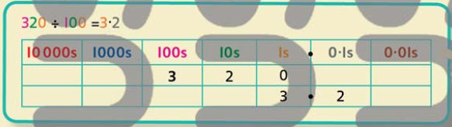
Now you try…
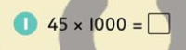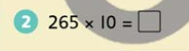

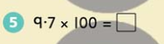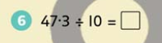

Year 6 Maths
Expected/ Greater depth activity
Lesson 2
LO: TBAT multiply and divide by 10, 100 and 1000.
Task:
You are going apply your knowledge of multiplying by 10, 100 and 1000 to solve several problems.
Success Criteria:
- Identify the operation.
- When you are dividing numbers, they become smaller and the digits must move to the right.
- When multiplying numbers they become bigger and the digits must move to the left.
- The amount of zeros there are in a number indicates how many spaces the digits must move.

Recap:
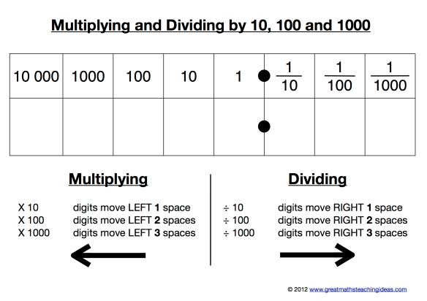
Year 6 Maths
Main activity
Complete at least 2 columns, more if you can!
Task 1 | Task 2 | Task 3 | Task 4
Practice  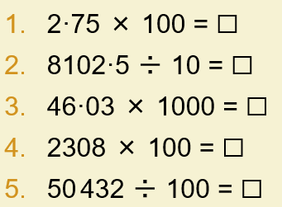  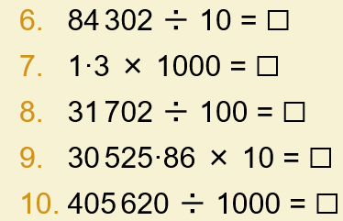  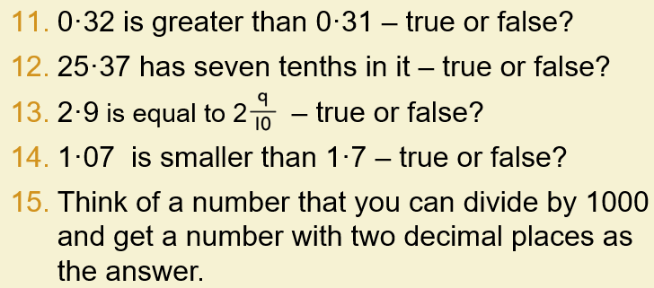 | Arithmetic  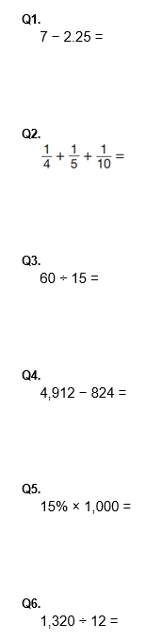 | Reasoning  Explain your answers.  Task 1  Write the missing number to make this division correct.  Task 2  Circle the number that is 10 times greater than nine hundred and seven.  9,700 907 9,007 970 9,070  Task 3  Here are five number cards.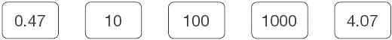  Use four of the cards to complete these calculations.  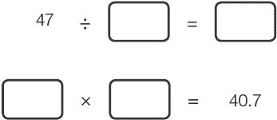 | Problem solving  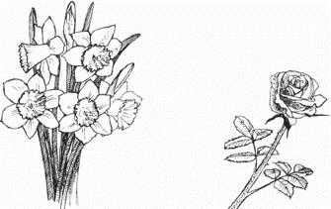  Task 1  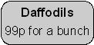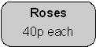  John buys 3 bunches of daffodils.  How much does he pay altogether?  Karpal has £4.00 to spend on roses.  How many roses can she buy for £4.00?  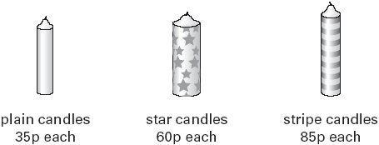  Task 2  A shop sells candles.  Sapna buys 4 star candles and 2 stripe candles.  How much does she pay altogether?

