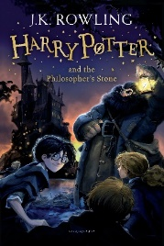
Year 6 Reading
Week 2, Lesson 2
LO: To retrieve and record information from a text.
Success Criteria:
- Read each question and identify the key words.
- Skim and scan through the chapter to find the answer to each question, based on the page number given.
- Write your answer in short form (not full sentences).
- Remember that you will always find the answers to, ‘retrieve and record’ type questions from the text. Aim to spend less than 1 minute per question!
Questions
- What noise woke Harry up? (Page 20)
- Why did Harry appear smaller and skinnier than he actually was? (Page 21)
- How did Harry feel when he found out that Mrs Figg could no longer look after him? (Page 23)
- Who was at the door when the bell range? (Page 25)
- Why was Harry hidden on his school roof? (Page 26)
- On which day did the family visit the zoo? (Page 27)
- Where did the snake that Harry was talking with come from? (Page 29)
- What was the zoo keeper most shocked about? (Page 30)
- How did Harry’s parents’ die? (Page 31)
- Who did Harry play with at school? (Page 32)

