Developing | Task 1 | Task 2 | Task 3
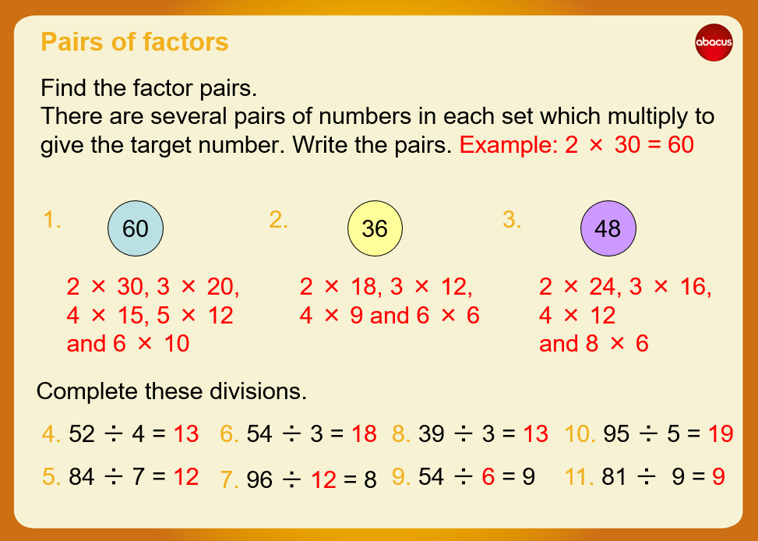 | Developing Task Answers  Task 1  12 = 1, 2, 3, 4, 6, 12.  20 = 1, 2, 4, 5, 10, 20.  17 = 1, 17  28 = 1, 2, 4, 7, 28  112 = 1, 2, 4, 7, 8, 14, 16, 28, 56, 112  64 = 1,2,4,8,16,32,64  Task 2  7 = 1, 7  11 = 1, 11  17 = 1, 17  23 = 1, 23  47 = 1, 47  They are all prime numbers. | Reasoning  Explain your answers.  - 10, 6, 2  - 5 and 2 and 1  - 7 and 3 | Problem solving  Task 1  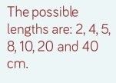  Task 2  