Year 5 Science
Lesson 2
LO: To recognise how physical features can change an animals character.
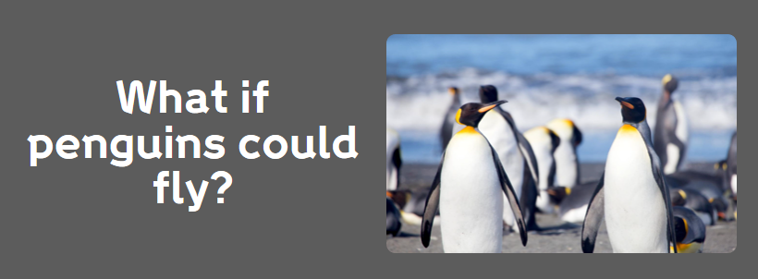
Background info:
Flightless birds all evolved from their flying ancestors. Being able to fly could make life in the Antarctic much easier for penguins. The gruelling march of the emperor penguins would take a few hours, if flown, rather than many days! Escaping predators, such as leopard seals would be easier.
In nature, adaptations are usually related to survival and reproduction. Scientists believe penguins stopped being able to fly as it is likely there were no predators where they lived long ago. Penguins rely on the oceans for food and have adapted over time to become more aquatic, exchanging wings for flippers. The changes to their wings and increasing body size allowed them to become more efficient for swimming and diving, but reduced their ability to fly. Penguins sacrificed flight for an incredible ability to dive.

Task:
Think about these questions. How would a penguin’s life be different if it could fly?
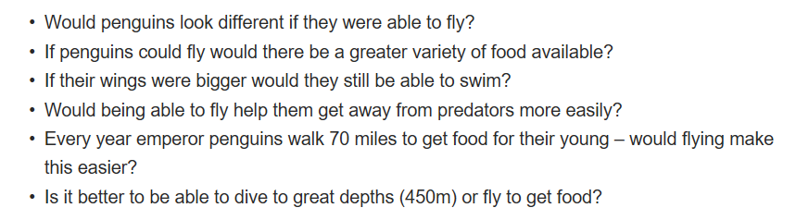
Draw a picture/ make a poster and label it to show your ‘NEW’ penguin – annotate with answers to the questions above.

