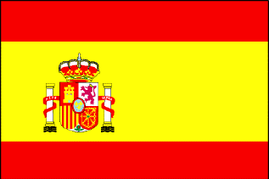
Year 5 Spanish

Year 5  Spanish Online Home Learning  Week2 | Picking fruit on a farm in Spain  ¡Hola! Dear Year 5. ¿Como estas? I am well and missing you all. I have prepared some activities for you to practice your Spanish at home. This week you will only focus on this activity. I will be sending more in the following weeks.  https://www.bbc.co.uk/bitesize/clips/zwp76sg  Introduction: A group of Spanish children visits Vicente's farm. They help him pick fruit from the trees. After a tiring day they go to see what happens to the fruit after it has been collected. They follow the process of weighing it, packing it and getting it ready to go to the shops, not just in Spain but all over Europe.  Activity: Children could research the process of a different item of fruit or vegetable making its way from farm to shop and create their own flow chart. Draw a picture. What words can you recognize from the clip?

