Year 6 Science
Week 2
Success Criteria:
- Pick your favourite science topic.
- Use websites to refresh knowledge.
- Choose either Kahoot or scratch to create your quiz.
- Complete quiz.
- Test your family and/or friends.
Task (with links):
Think of a Science topic that you have learnt about at Canonbury. For example…
- Space
- The digestive system
- Rocks
Complete some research, to refresh your knowledge and then choose either Scratch or Kahoot to create a quiz. Then test your parents and/ or friends.
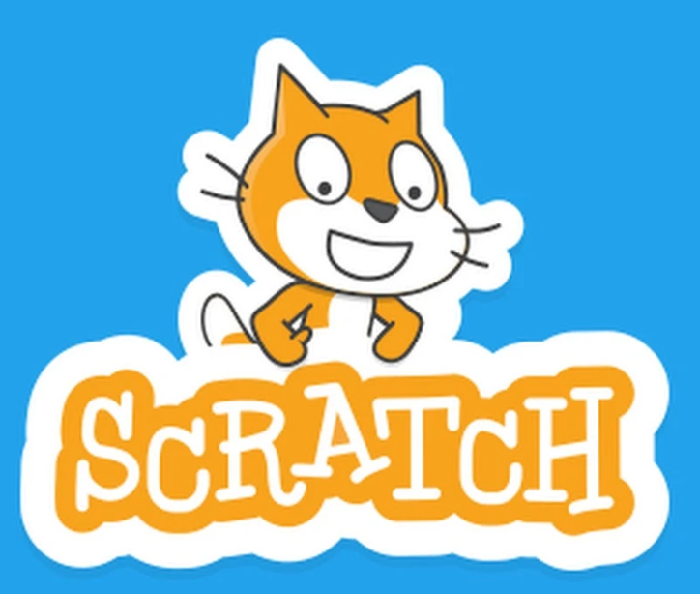

Helpful websites.
https://www.bbc.co.uk/programmes/articles/1vYCLNlGK2wdM8R9FqhVxhV/class-clips-primary
https://www.bbc.co.uk/bitesize/subjects/z2pfb9q
https://www.lgfl.net/learning-resources/grid

