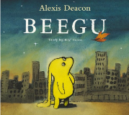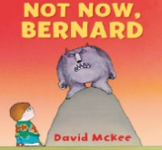

**Year 1**

**Curriculum Overview**

**Autumn Term 2025**

**Maths**We will begin by revising the following areas:

* **Number:** Representing numbers (within 10)
* **Addition and Subtraction** (within 10)
* **Geometry:** Shapes and their properties
* **Number:** Place Value and partitioning (within 20)

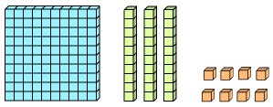



We will be using both concrete objects (such as; counters, cubes, and compare bears) and pictorial representations to aid the children with their understanding of number.

**English**

Our writing will be based on a range of books including Not Now Bernard by David Mckee, and Beegu by Alexis Deacon.

In our writing we will be focusing on writing in complete sentences using finger spaces, capital letters and full stops.

In Handwriting, we will be practising forming letters correctly, using ditties (rhymes) to help us.

In Phonics, we will be split into groups across KS1 and continue with the Read, Write, Inc programme that the children started in Reception.

**Science**

This term we will be learning about **Everyday Materials**. Children will:

* identify and name a variety of everyday materials, including wood, plastic, glass, metal, water, and rock
* compare and group together a variety of everyday materials on the basis of their simple physical properties
* distinguish between an object and the material from which it is made

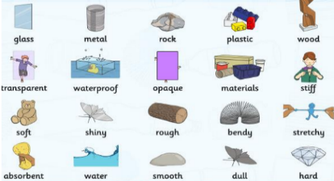

**History and Geography**

During the first half term, our Topic will be Geography focussed and the children will be learning all about our local area. We will take the children on a walk around the area to see which Islington landmarks we recognise and discuss why they are important. The children will learn the difference between human and physical geographical features.

After half term our topic will remain on Canonbury, but our focus will be History and any changes (or not) that the school has made over time.

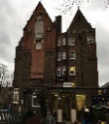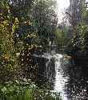

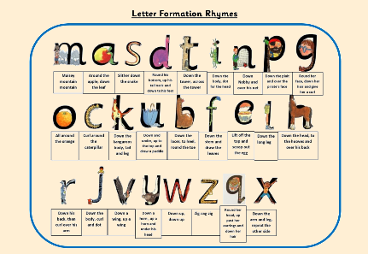

**Physical Education**

Multi-skills: Our sports coaches from Team Kick Start will deliver lessons outside using an integrated approach, where children learn to coordinate a wide range of fundamental movement skills in various sports activities within each lesson.

The focus of the teacher led PE lessons will be fundamentals and team building.

**We have PE on Monday & Tuesday.**

**How to help your child**

Reading aloud with your child is important, so please encourage your child to read every day.

Remind children to bring their reading records and reading books to school each day, recording when they have read at home.

We will not be sending homework out for Year 1 until the Summer Term. This is so that the children do not feel overwhelmed and to allow the focus at home to remain on reading.

Your child should bring a water bottle to school. Please make sure the water is changed daily!

**Calculation Policy**

[**https://canonburyprimaryschool.co.uk/wp-content/uploads/2024/04/Calculation-Policy.pdf**](https://canonburyprimaryschool.co.uk/wp-content/uploads/2024/04/Calculation-Policy.pdf)

**Art**

In Art, the children will make observational drawings of leaves and make rubbings to create pictures of different trees found in Islington.

They will learn about the artist, Pablo Picasso, and develop their drawing skills to create abstract self-portraits.

**Religious Education**



This focus for this term is: Christians and what they believe.

The children will:

* Talk about some simple ideas about Christian beliefs.
* Re-tell some Christian stories.
* Talk about issues of right and wrong.
* Ask question about believing in god.

**Music**

Using Charanga, the children will learn warm up techniques, melody and the key skills of breathing through learning a whole class song.



**Design and Technology**

The children will be using felt to make Beegu finger puppets. They will cut the alien’s shape using a template and then use either sewing or sticking to attach the pieces of fabric.

**PSHE**

We will be looking at physical health and wellbeing. We will cover:

* Active playgrounds and games
* Food and its association to special times and cultures.
* Sun-safety
* Physical and mental wellbeing

**Gardening/The Glade**

The children will have the opportunity to work and learn in the garden and/or the Glade every week.

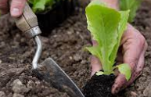

**Computing**

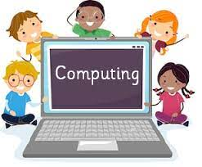 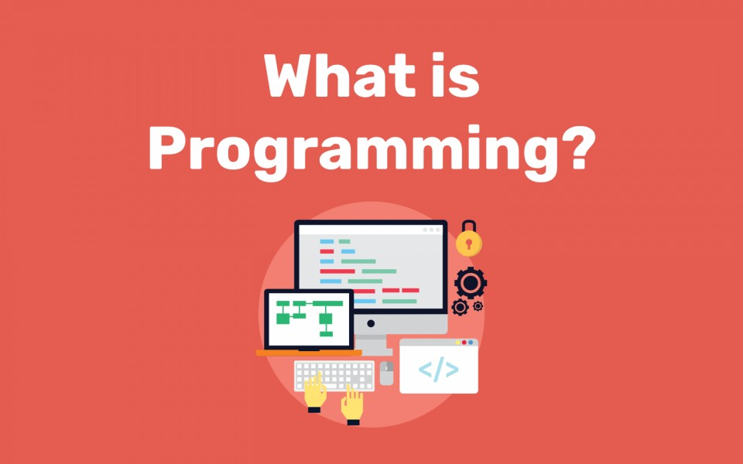

Programming – Computer Science

E–Safety – Digital Literacy