

**Year 2 Curriculum Information**

**Autumn 2025**



**Science**

In our topic ‘Everyday Materials’, we will be working scientifically to observe, identify and classify a range of different materials. We will consider how we can describe materials using scientific properties and think about how these properties make materials suitable for specific purposes.

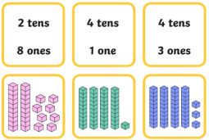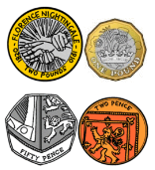

**Maths**

This term we will be focusing on the following areas:

* **Number:** Place value
* **Number:** Addition and subtraction
* **Measurement:** Money
* **Number:** Multiplication and division

We will develop our understanding of new mathematical skills using the concrete, pictorial and abstract approach.

**English**

For our first text this term, we will be taking an adventure with ‘Katie in London’ by James Mayhew.

Later in the term we will read ‘Toby and The Great Fire of London’. We will use these books to help develop our vocabulary, sentence-writing and narrative skills.

We will also look at non-fiction texts and write our own non-fiction text about London and The Great Fire of London.

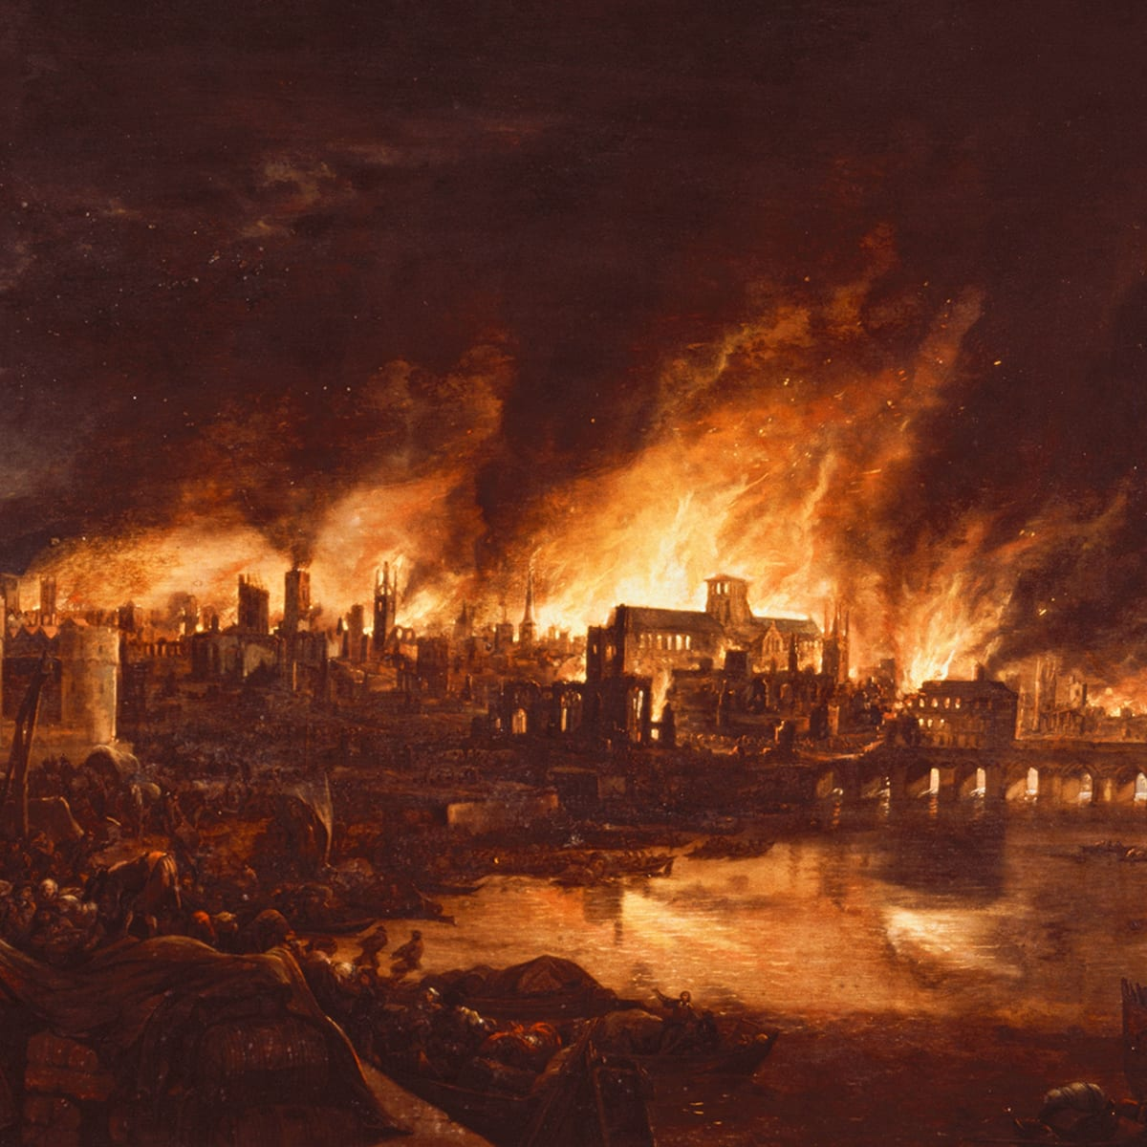

**History and Geography**

Our Topics this Autumn term are **London Landmarks** and **The Great Fire of London**.

We will be looking at where London is in the world and significant London landmarks. In Autumn 2, we will be going back in time to learn about how and when the Great Fire of London happened. We will carefully study a range of sources to find out as much as we can about the past.

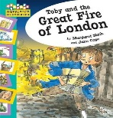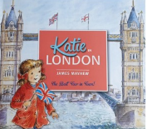

**Art**

* London landmarks collages.
* Mixed-media fire pictures.

**Religious Education** 

**Who is Jewish and what do they believe?**

* What is precious to us and Jewish people?
* What does a mezuzah remind Jewish people about?
* How and why do Jewish people celebrate Shabbat?
* What does the story of Chanukah make us think about?

**Physical Education**

Multi-skills: Our sports coaches from Team Kick Start will deliver lessons outside using an integrated approach, where children learn to coordinate a wide range of fundamental movement skills in various sports activities within each lesson.

**How to help your child this term:**

* Listening to your child read and reading to them is important, so please try to do this every day.
* Please record what they have read in their reading record. Remind children to bring their books and reading records to school on their book changing day.
* We will send home weekly homework based on what we have been learning in school that week. Please encourage your child to have a go at these activities.

**Homework Policy**

<https://canonburyprimaryschool.co.uk/wp-content/uploads/2015/12/Homework-Policy-CPS-2023_12.pdf>

**Calculation Policy**

[**https://canonburyprimaryschool.co.uk/wp-content/uploads/2024/04/Calculation-Policy.pdf**](https://canonburyprimaryschool.co.uk/wp-content/uploads/2024/04/Calculation-Policy.pdf)

.

**Design and Technology**

We will using what we have learnt in our History to design and make moving Great Fire of London pictures with levers.

**Music**

We will be using the Charanga lesson sequence, focussing on keeping a steady beat, singing, listening to music and using instruments.

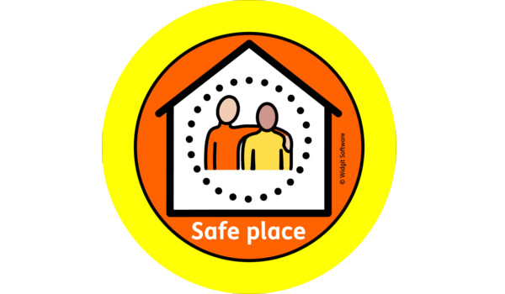**Personal, Social, Health Education**

* Physical health and wellbeing: **What keeps me healthy?**
* Mental health and emotional wellbeing: **Friendship**.

**Spanish**

* Greetings
* Feelings
* Me gusta … (I like…)
* Numbers 1 – 30
* Classroom items
* Months
* Birthdays
* Christmas

**Computing**

* E-safety
* Uses of computers
* Digital Media and Writing