**Science**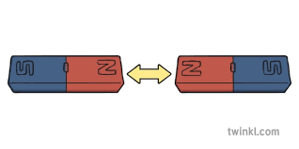

In ourtopic on **Forces and Magnets,** we will observe how magnets attract or repel each other. We will compare and group together a variety of everyday materials based on their magnetism and investigating the strength of different magnets.

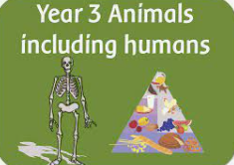

In our topic on **Animals including humans** we will look at what animals need to survive focussing on a balanced diet. We will then look at the human skeleton and discuss how our muscles work.

**History and Geography**



Our topic this term is **London Transport Then and Now.**

In **History** We will learn about the history of transport in London and how it has changed over time. We will look at a range of primary sources to help us find out about the past.

In **Geography** we will use maps to plan journeys and form opinions about the positive and negative impacts of different modes of transport in our city.

**Year 3**

**Curriculum Overview**

**Autumn 2025**

**Maths**

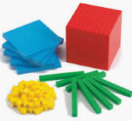We will develop our understanding of new mathematical skills using the concrete, pictorial and abstract approach.

* **Number:** Place value -

Read, write, compare and order numbers up to 1000 and recognise place value of three-digit numbers.

* **Number:** addition and subtraction of numbers up to 3-digits mentally and using column methods.
* **Number:** recall and use multiplication and division facts for 3, 4 and 8 times tables and use these within formal written methods.

**English**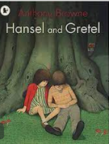

We will be consolidating Year 2 writing features to ensure that all children have a firm basis upon which to build the Year 3 English Curriculum. We will begin with looking at traditional fairy tales focussing particularly on Hansel and Gretel.

We will also be writing information texts based on our History and Geography learning.

**Spanish**

Spanish in the world. They will learn to greet each other and ask simple questions about name and wellbeing. There will be a strong emphasis on the correct pronunciation of key sounds in Spanish.

**Music**

Children will all be given a recorder and learning to play the instrument with a specialist music teacher.



**Computing**

* E-safety
* Programming

**PSHE**

* Mental health and emotional wellbeing: Strengths and challenges
* Leader in Me: 7 Habits

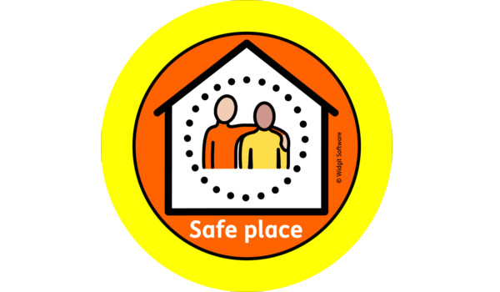

**Physical Education**

Multi-skills: Our sports coaches from Team Kick Start will deliver lessons outside using an integrated approach, where children learn to coordinate a wide range of fundamental movement skills in various sports activities within each lesson.

Teachers will teach a range of traditional folk dances.

**How to help your child**

* Reading aloud with your child is really important, so please encourage your child to read at least 5 times a week.
* **Homework Policy**

[https://canonburyprimaryschool.co.uk/wp-content/uploads/2015/12/Homework-Policy-CPS-2023_12.pdf](https://emea01.safelinks.protection.outlook.com/?url=https%3A%2F%2Fcanonburyprimaryschool.co.uk%2Fwp-content%2Fuploads%2F2015%2F12%2FHomework-Policy-CPS-2023_12.pdf&data=05%7C02%7C%7C44e9dbee39074d2b08d808dc4e87626f%7C84df9e7fe9f640afb435aaaaaaaaaaaa%7C1%7C0%7C638471590569621965%7CUnknown%7CTWFpbGZsb3d8eyJWIjoiMC4wLjAwMDAiLCJQIjoiV2luMzIiLCJBTiI6Ik1haWwiLCJXVCI6Mn0%3D%7C0%7C%7C%7C&sdata=VsioWa5zXyJctIPlUXC28KJab4DGxc%2FRAU1CohiX5DU%3D&reserved=0)

* **Calculation Policy**

[**https://canonburyprimaryschool.co.uk/wp-content/uploads/2024/04/Calculation-Policy.pdf**](https://canonburyprimaryschool.co.uk/wp-content/uploads/2024/04/Calculation-Policy.pdf)

* Remind children to bring their reading records and reading books to school each day.
* Please name your child’s clothing.
* Children may bring a piece of **fruit or vegetable** for a snack at break time.
* Encourage your child to practise their recorder ready for lessons every **Wednesday**.

**Design and Technology**

**Food:** 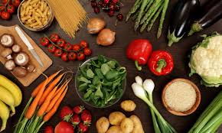

To design, make and evaluate a healthy product, looking at sandwiches, rolls and wraps.

**Art**

Creating art inspired by London Transport – making maps, mixing colours to paint the tube map and printing. 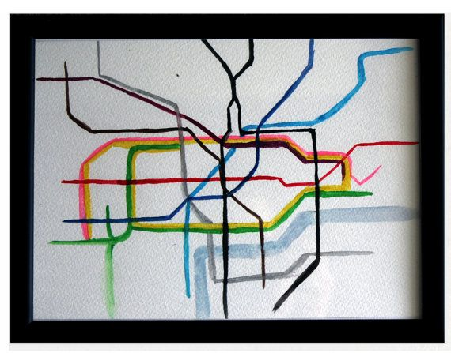

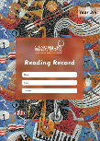

**Religious Education**



We will be exploring what different people believe about God.

**Music - Recorder**

* Reading musical notation
* Rhythm and pulse
* Listening skills



**PSHE**

* **Mental health and emotional wellbeing:**

Strengths and challenges

* **Keeping safe and managing risk:**

Bullying - See it, Say it, Stop it



**Spanish**

* Greet each other, asking and answering names and about wellbeing
* Recognise aurally and in written form the numbers 1 – 20
* Respond to simple classroom commands
* Pronounce some of the key Spanish sounds correctly.

**Computing**

* E-safety
* Digital Literacy – Understanding how devices work
* [Creating media – Desktop publishing + Blogging](https://docs.google.com/document/d/1HLLCAEZjwNK5QJDFMHuzR8sfr95yqGsECSKmeeldRyA/edit?usp=sharing)