**History and Geography**

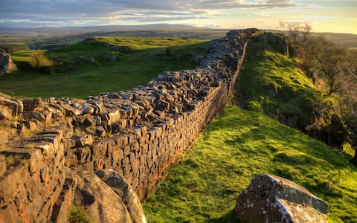

With our topic ‘Roman Rule’, we will use primary and secondary sources to learn who the Romans were and where they came from; explore key concepts related to ‘invading’ and ‘settling’; Understand what made the Roman Army so powerful and formidable; understand the factors that led to the fall of the Roman Empire; identify how the Romans have influenced our lives today.

We will primarily be looking at the time of the Roman’s invasion of Britain and their reign here.

**Science**



In ourtopic about **electricity,** we will be learning how to keep safe around electricity, how to build a simple circuit, common insulators and conductors and building an electric circuit game.

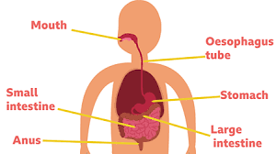

In the second half of the term, we will be learning about ‘**animals including humans’**, describing the basic functions of the digestive system in humans, identifying the different types of teeth, constructing and interpreting a variety of food chains.

**Year 4**

**Curriculum Overview**

**Autumn 2025**

**English** 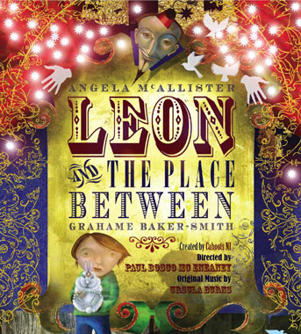

The term begins with **‘Leon and the Place Between’** which transports us to a circus, we will be producing a fantasy narrative based on the story

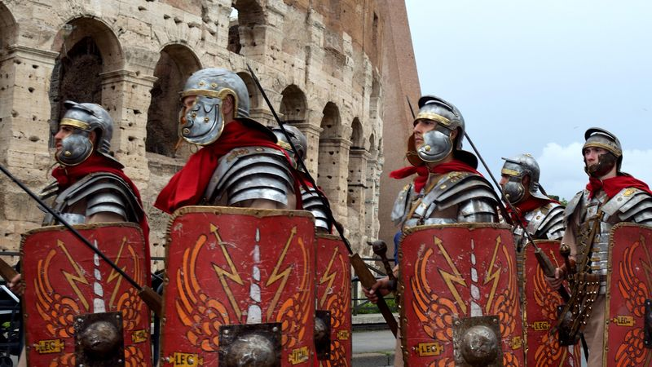

We will then move onto non-fiction texts. We will be using the features of this genre to write our own non-fiction pieces based on the Romans.

**Maths**



We will develop our understanding of new mathematical skills using the concrete, pictorial and abstract approach.

* **Number:** Place value – looking at numbers up to 10,000 and their place value, also looking at Roman Numerals.
* **Number:** addition and subtraction of 4-digit numbers including column methods and estimating and rounding.
* **Number:** multiplication and division, focussing on times tables including division facts and multiplying up to 3 numbers.

**Spanish**

Spanish in the world. They will learn to greet each other and ask simple questions about name and wellbeing. There will be a strong emphasis on the correct pronunciation of key sounds in Spanish.

**Music**

Children will all be given a recorder and learning to play the instrument with a specialist music teacher.



**Computing**

* E-safety
* Programming

**PSHE**

* Mental health and emotional wellbeing: Strengths and challenges
* Leader in Me: 7 Habits

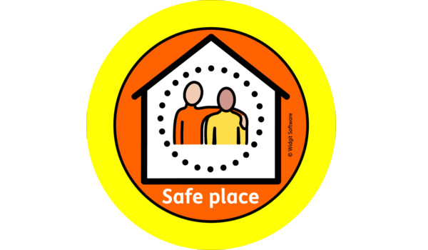

**Physical Education**

Multi-skills: Our sports coaches from Team Kick Start will deliver lessons outside using an integrated approach, where children learn to coordinate a wide range of fundamental movement skills in various sports activities within each lesson.

**How to help your child**

Reading aloud with your child is really important, so please encourage your child to read at least 5 times a week.

Help them to remember their **recorder** on a Tuesday and to a little bit of **practice** several times a week.

Please **practice timetables** in as many ways, and as often as possible - the expectation is that all children know all times tables and related division facts by the end of Year 4.

Children may bring a piece of fruit or vegetable for a **snack** at break time, this will keep them going until lunchtime.

Homework is set every **Friday** and should be brought in every **Wednesday.**

Homework Policy:

[https://canonburyprimaryschool.co.uk/wp-content/uploads/2015/12/Homework-Policy-CPS-2023_12.pdf](https://emea01.safelinks.protection.outlook.com/?url=https%3A%2F%2Fcanonburyprimaryschool.co.uk%2Fwp-content%2Fuploads%2F2015%2F12%2FHomework-Policy-CPS-2023_12.pdf&data=05%7C02%7C%7C44e9dbee39074d2b08d808dc4e87626f%7C84df9e7fe9f640afb435aaaaaaaaaaaa%7C1%7C0%7C638471590569621965%7CUnknown%7CTWFpbGZsb3d8eyJWIjoiMC4wLjAwMDAiLCJQIjoiV2luMzIiLCJBTiI6Ik1haWwiLCJXVCI6Mn0%3D%7C0%7C%7C%7C&sdata=VsioWa5zXyJctIPlUXC28KJab4DGxc%2FRAU1CohiX5DU%3D&reserved=0)

Link to the Calculation Policy:

<https://canonburyprimaryschool.co.uk/wp-content/uploads/2024/04/Calculation-Policy.pdf>

**Art**

We will look at the significance of Roman mosaic art, creating our own mosaics using a variety of materials.

We will continue to produce Roman inspired art looking at the use of sketchbooks and working collaboratively on group pieces.

**Spanish**

* Greet each other, asking and answering names and about wellbeing
* Recognise aurally and in written form the numbers 1 – 20
* Respond to simple classroom commands
* Pronounce some of the key Spanish sounds correctly.

**Religious Studies**

Question: **Why is Jesus inspiring to some people?**

* Making connections between Jesus’ teachings and how Christians live today.
* Describing how Christians celebrate Holy week and Easter Sunday
* Identifying the most important parts of Easter for Christians.

**PSHE**

Mental Health and wellbeing.

Identity, society and equality: **Democracy**

**Music - Recorder**



We will continue our recorder lessons every Wednesday afternoon.

**Computing**

* Online safety – looking at our roles and responsibilities when online.
* Audio Editing – recording, producing and editing podcasts.

**Design & Technology**

We will be designing and making our own Christmas light up cards, incorporating our learning from our science lessons.