**Science**

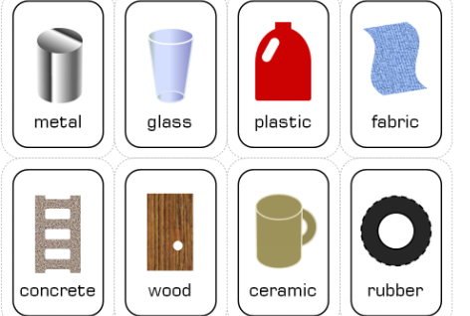

In ourtopic on **Materials and their properties,** we will be discussing characteristics of different materials, testing materials in a variety of ways and using our investigative skills to plan a range of fun scientific experiments.

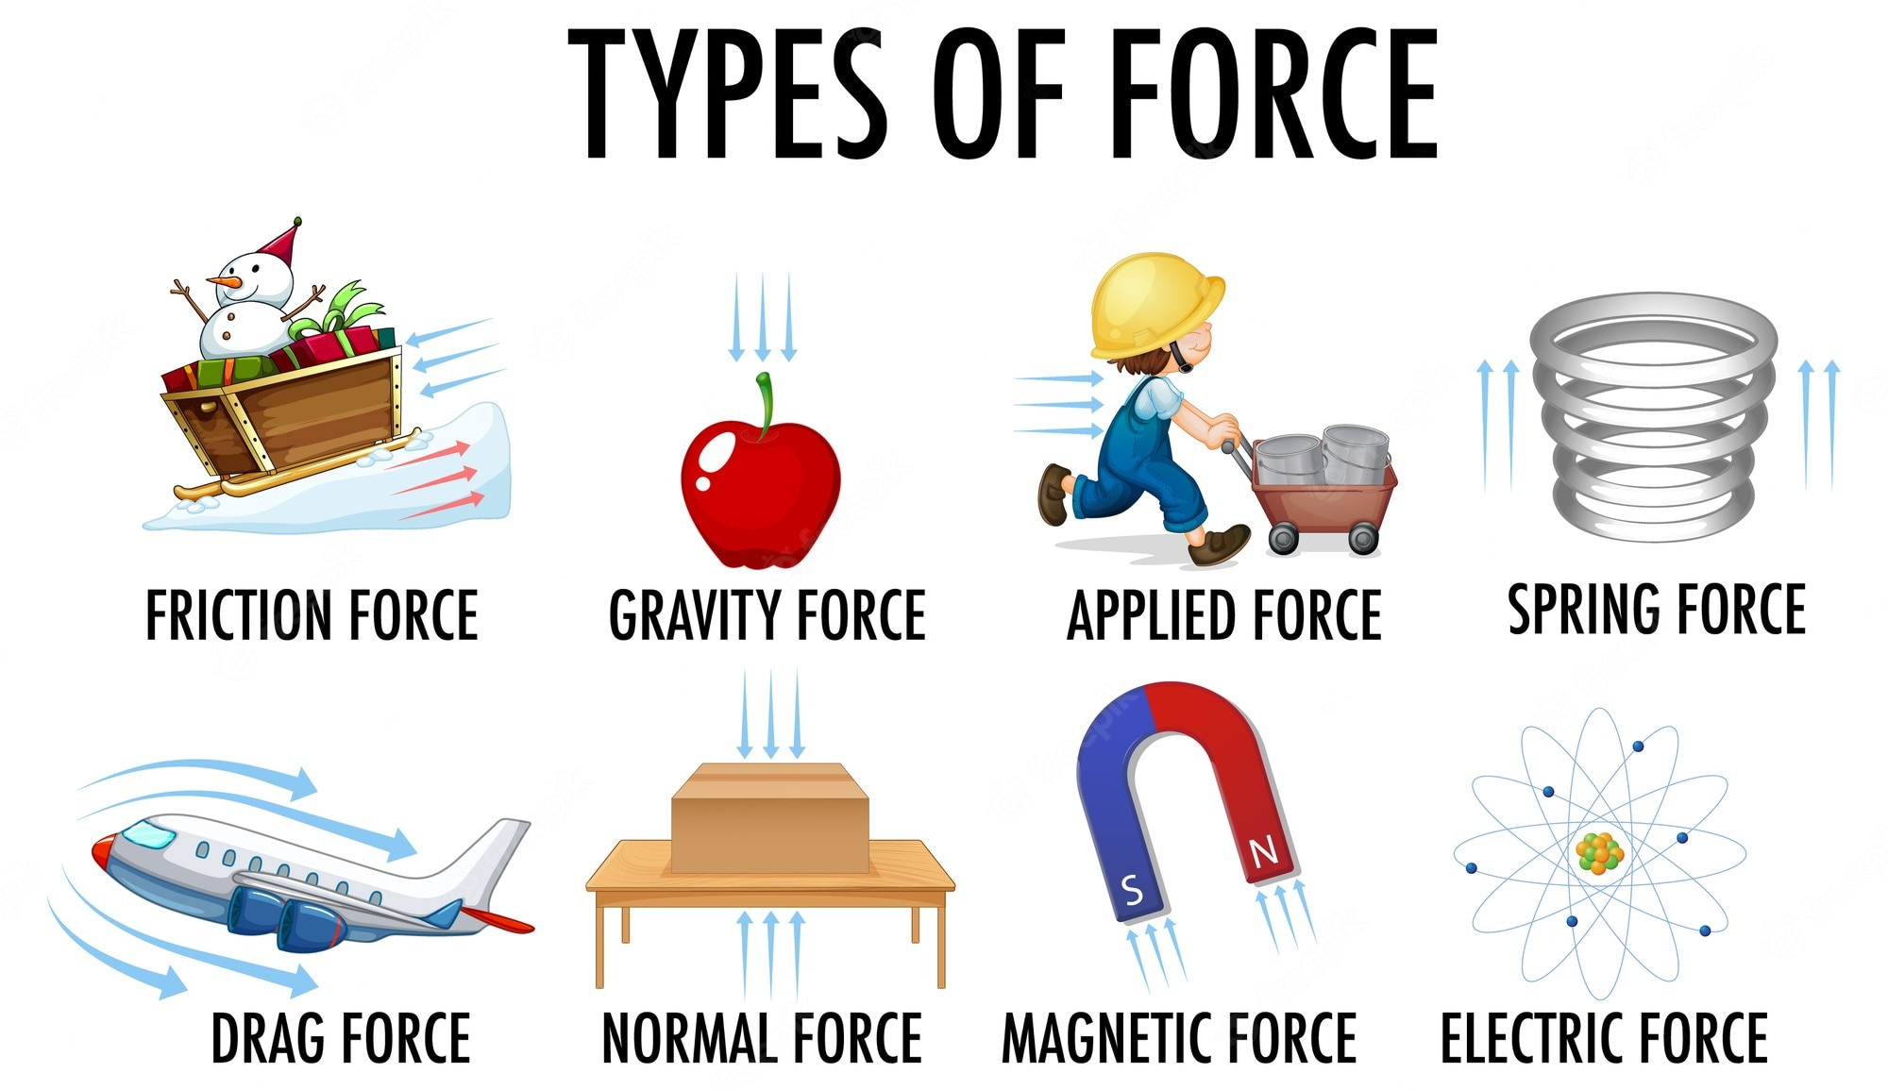

While studying **Forces**, we will be investigating a range of forces including air and water resistance and testing ideas using a range of fair tests. These will include practical activities and problem solving.

**History and Geography**

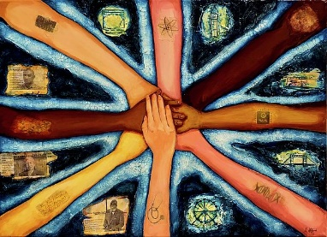

We will begin by learning about population density, the make up of London’s population and how this has evolved over time.

We will identify the push and pull factors for migration in general and compare this to the children’s own family experiences.

We will move onto exploring some of the migrant communities that make London such a vibrant city to live in.

**Year 5**

**Curriculum Overview**

**Autumn 2025**

**Maths**

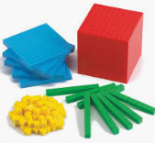

We will begin by working on skills and concepts in the following areas of **number:**

**Place value** – numbers up to 1,000,000

**Addition and subtraction** – adding and subtracting mentally with increasingly large numbers

**Multiplication and division –** multiples, factors, squares and cubes

**Fractions** – equivalent fractions up to tenths and hundredths

We will develop our understanding of new mathematical skills using the concrete, pictorial and abstract approach.

**English** 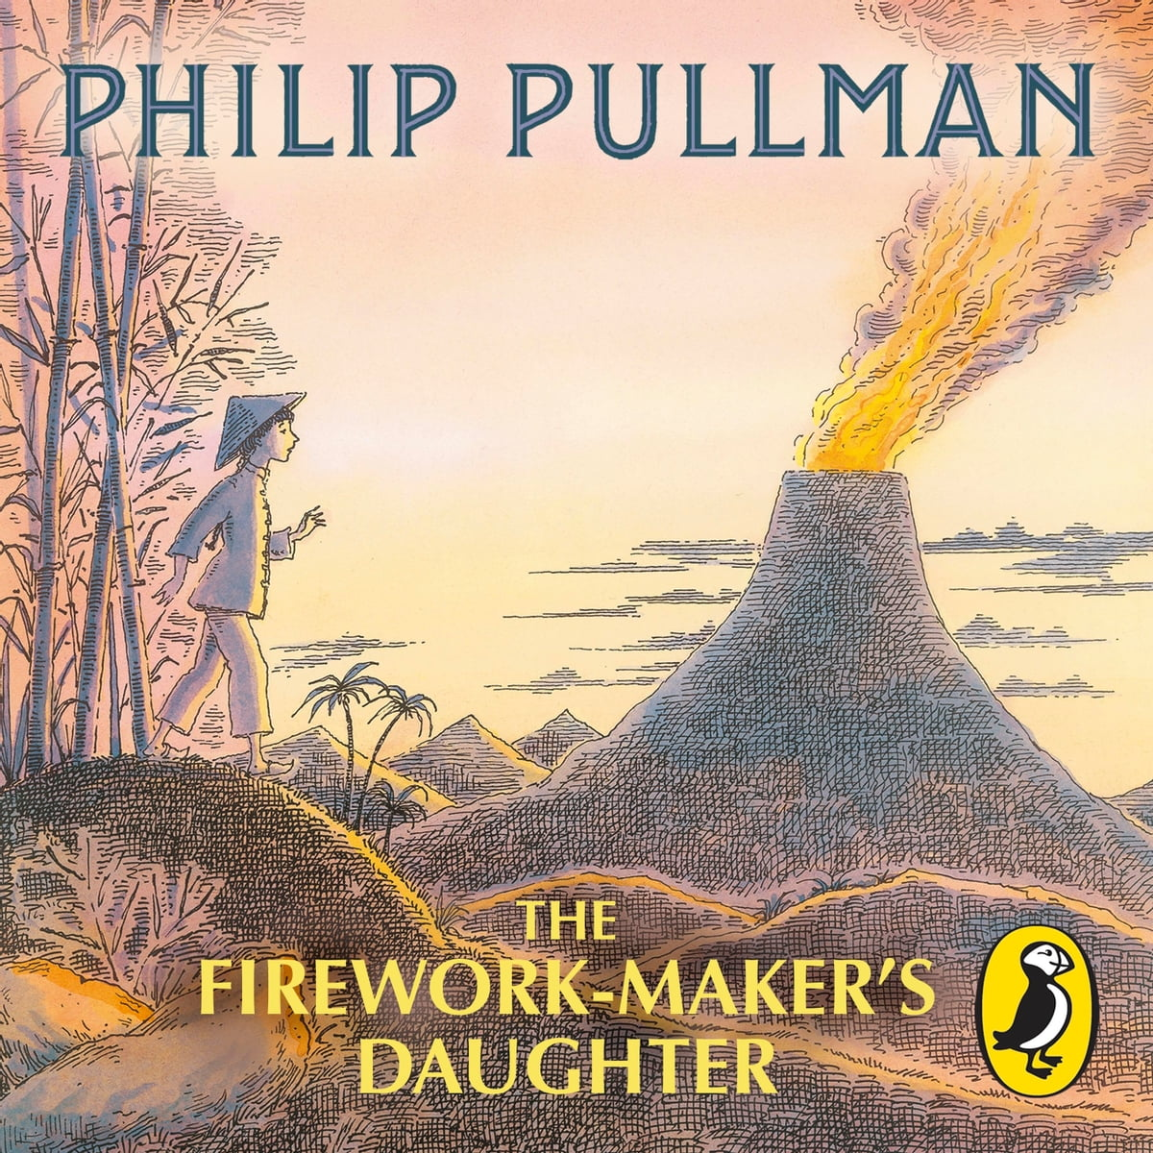

The term begins with **‘The Firework Maker’s Daughter’** which transports us to Indonesia and a quest up a volcano. Our writing outcome is an adventure narrative about the descent of the volcano.

In Autumn 2, we will be working our debate skills and this will involve reading and writing balanced arguments. In addition, we will improve our oracy through formal debates.

**Spanish**

Spanish in the world. They will learn to greet each other and ask simple questions about name and wellbeing. There will be a strong emphasis on the correct pronunciation of key sounds in Spanish.

**Music**

Children will all be given a recorder and learning to play the instrument with a specialist music teacher.



**Computing**

* E-safety
* Programming

**PSHE**

* Mental health and emotional wellbeing: Strengths and challenges
* Leader in Me: 7 Habits

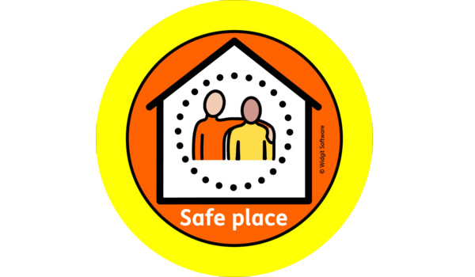

**How to help your child**

Please encourage your child to **read** every day. We will check reading records and children who work hard to complete them, will receive lots pf dojos!

Please take the opportunity to **share a book** with your child that you read to them.

Help them to remember their **brass instrument** on the correct day and to do a little bit of **practice** several times a week. This will make a huge difference to their progress and enjoyment.

Children may bring a piece of fruit or vegetable for a **snack** at break time. This will keep them going until lunchtime.

**Homework Policy**

[https://canonburyprimaryschool.co.uk/wp-content/uploads/2015/12/Homework-Policy-CPS-2023_12.pdf](https://emea01.safelinks.protection.outlook.com/?url=https%3A%2F%2Fcanonburyprimaryschool.co.uk%2Fwp-content%2Fuploads%2F2015%2F12%2FHomework-Policy-CPS-2023_12.pdf&data=05%7C02%7C%7C44e9dbee39074d2b08d808dc4e87626f%7C84df9e7fe9f640afb435aaaaaaaaaaaa%7C1%7C0%7C638471590569621965%7CUnknown%7CTWFpbGZsb3d8eyJWIjoiMC4wLjAwMDAiLCJQIjoiV2luMzIiLCJBTiI6Ik1haWwiLCJXVCI6Mn0%3D%7C0%7C%7C%7C&sdata=VsioWa5zXyJctIPlUXC28KJab4DGxc%2FRAU1CohiX5DU%3D&reserved=0)

**Calculation Policy**

[**https://canonburyprimaryschool.co.uk/wp-content/uploads/2024/04/Calculation-Policy.pdf**](https://canonburyprimaryschool.co.uk/wp-content/uploads/2024/04/Calculation-Policy.pdf)

**Physical Education**

Multi-skills: Our sports coaches from Team Kick Start will deliver lessons outside using an integrated approach, where children learn to coordinate a wide range of fundamental movement skills in various sports activities within each lesson.

**Art**



In Art this Autumn, we will be using a range of media to create Turkish lanterns. In addition we will be creating art inspired by Black History month.

**Spanish**



We will be learning how to speak and write about our families and pets through storytelling, songs and games.

**PSHE**

* Physical health and wellbeing in the media.
* Identity, society and equality

**Religious Education**

We will explore Jesus’ teachings and example and how they inspire Christians today. We will consider the extent to which Jesus’ values and example would benefit today’s world, within the school community, local and national communities and out to the global community.

**Music - Brass**

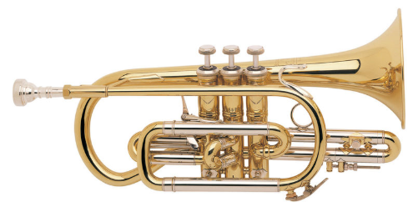

We will start our brass lessons with Connor, building on our musical skills. Lessons are every Tuesday.

**Computing**

* Online safety
* History of Computing
* Vector drawing

**Design & Technology**

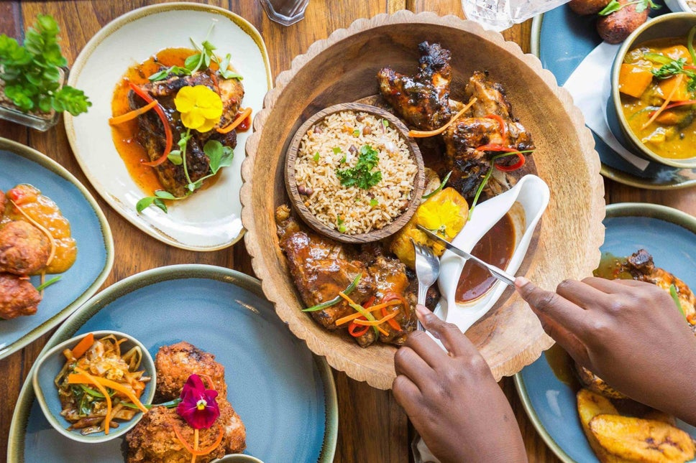 International cooking to link with our Diverse London topic.