**History and Geography**

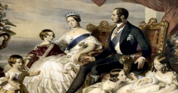

Over the term, we will be learning about the **Victorian** era. Broken into two parts, first we will look at Victorian London and what it was like living there.

Secondly, we will move on to ‘London Trade’. Through this, we will see the impact trade had to Victorian Britain and in London in particular. We will also link this to past and present trade links.

Throughout the topic, we will be using a number of sources, artefacts and enriching trips to retrieve our information for our learning.

**Maths**

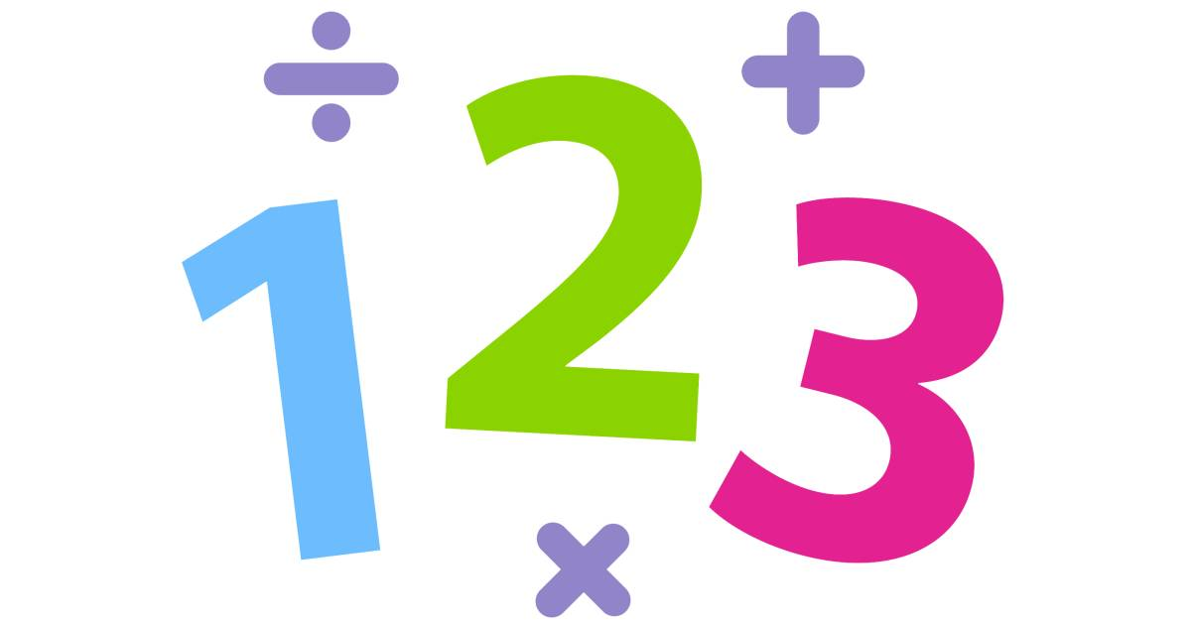

We will begin by revising the following areas:

**Number:** Place value

* To read, write and identify numbers up to 10 million.
* Comparing numbers and rounding numbers.

**Number:** Four Operations

* To add, subtract, multiply and divide up to 4 digit numbers

**Number:** Fractions

* To identify, order and compare fractions.
* To add, subtract, multiply and divide fractions

**Year 6 Curriculum Overview**

**Autumn Term 2025**

**Science**



In ourtopic on **Light,** we will be working scientifically to explore shadows, using our understanding of how light travels. There will also be exploration into the way that light behaves, in light sources, reflections and refraction.

Whilst studying **Electricity,** we will work scientifically by identifying the effect of changing one component at a time in a circuit. Furthermore, we will design and create a project which includes a light- up and moving part.

**English**

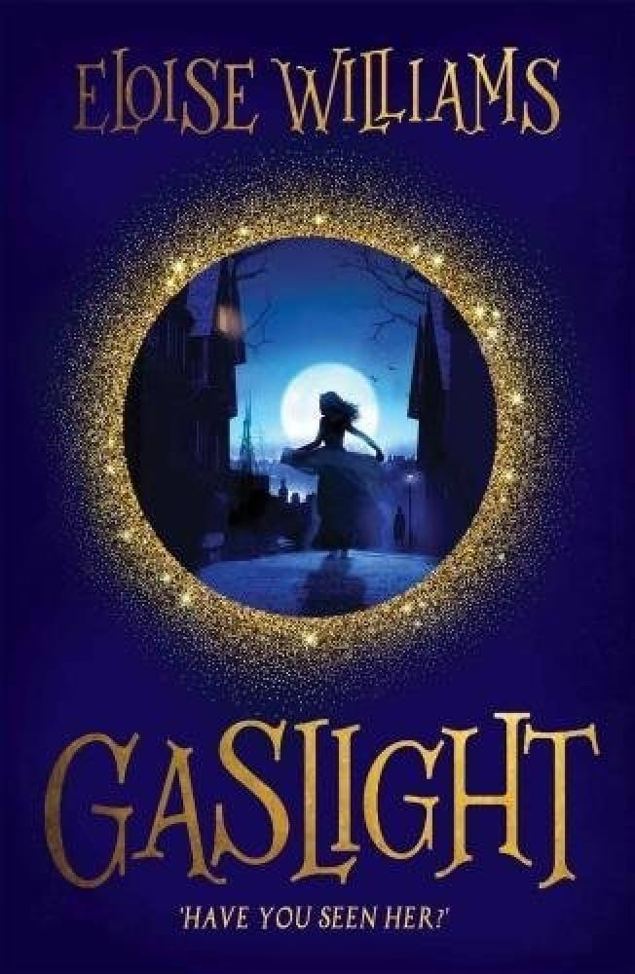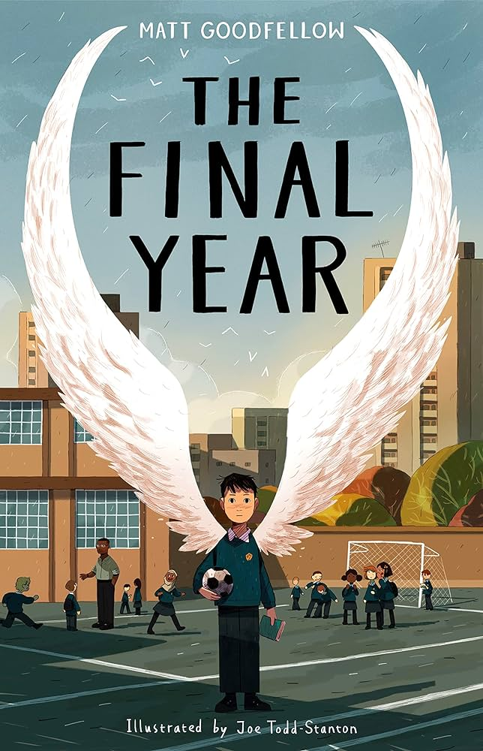

The term begins with **‘Gaslight’** which takes us back to the Victorian period, where we learn about the tribulations faced by young Nansi Howells.

In Autumn 2, we move onto a book set in modern times, but similarly exploring how a Year 6 child navigates their final year at primary school.

Our final writing outcomes include: a narrative, a diary entry and a letter. Additionally, fun opportunities for role play and debate.

**Physical Education**



Multi-skills: Our sports coaches from Team Kick Start will deliver lessons outside using an integrated approach, where children learn to coordinate a wide range of fundamental movement skills in various sports activities within each lesson.

**Religious Studies**

**Question: What questions have you got about what happens when we die?**

To express ideas about how and why religion can help believers when times are hard, giving examples.

Outline Christian, Hindu and/or nonreligious beliefs about life after death.

Explain some similarities and differences between beliefs about life after death.

**Art**

This term the children will be drawing Victorian houses, exploring the life of the artist William Morris and looking at his prints. In addition, creating their own block prints.

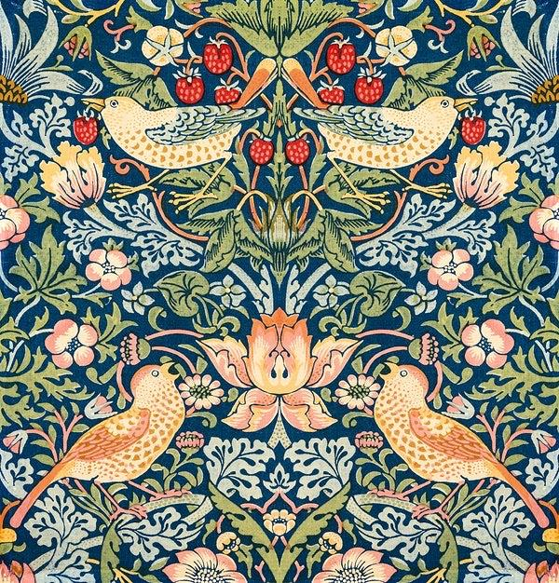

**How to help your child:**

Please ensure your child is **in school on time.**

Please encourage your child to **read** every day and record what they have read in their **Reading Record**. Please remind children to bring their Reading Record into school each week.

Please **return library books** by **Tuesday** each week and ensure your child has a bag on this day to take home their new library book.

We provide **homework** each week on a Friday. **Please ensure homework is completed and returned by Wednesday** so we can see how your children have been able to apply their learning from the week before and stick in their new homework.

**Design & Technology**

This term will have a focus on ‘Bridges’ – we will look at existing bridges and use a variety of materials to create our own.

**Music**

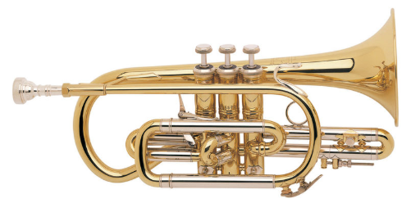

The children will continue to explore their given brass instruments every **Tuesday**.



**Spanish**

Geographical features. Children will revisit and build on their prior learning about weather and ways of expressing the current weather and to be able to produce a forecast of what the weather will be like. Poetry: Children will learn about the poet Pablo Neruda.

**PSHE**

* Mental health.
* Keeping safe and managing risks when things go wrong.

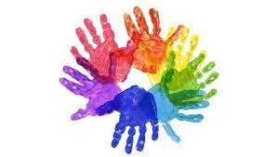

**Computing**

* Online safety
* Computing networks and Understanding the Creation and Workings of the Internet