Maths
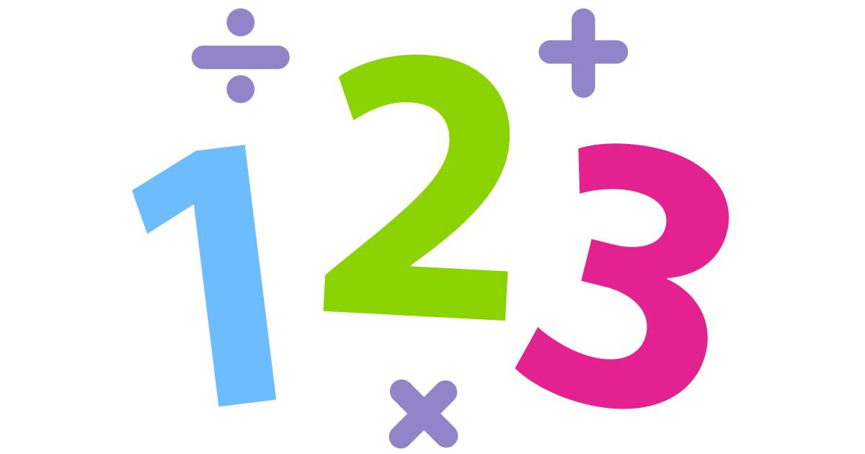
Geometry:
Position and Direction
- To read and plot points in four quadrants
- To solve problems with co-ordinates
- To translate and reflect

Number
Ratio
- To use ratio language and scale factors
Algebra
- To use form expressions and formulae

Statistics
- To read and interpret charts and graphs
- To work out the mean
Year 6 Curriculum Overview
Summer Term 2026
English

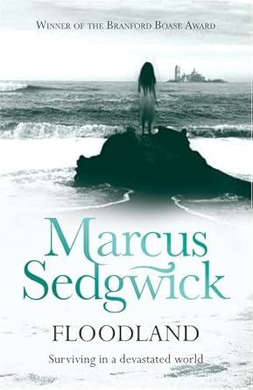
This term, we will look at ‘Floodland’: A gripping, prizewinning novel about a girl surviving in a devastated world.

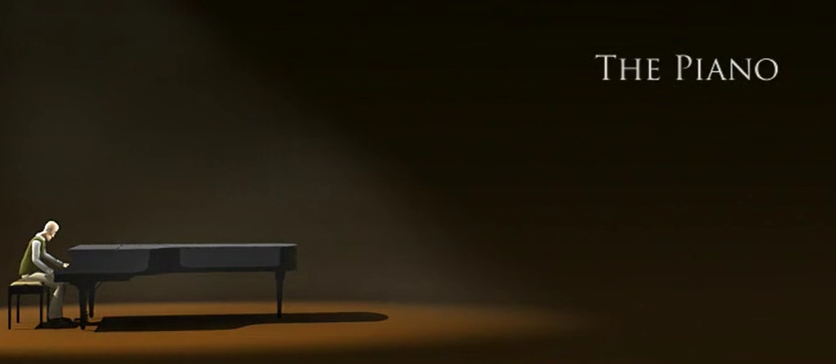
Next, we will use a short video for inspiration. ‘The Piano’ is exploring the profound bond between a father and daughter through music.

Science
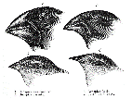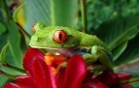
For our first topic this term, Evolution and inheritance, the children will consider different characteristics - which have been passed from one generation to the next - and how species have adapted to suit their environments. They will learn about the process of natural selection, and how our understanding of evolution has developed over time.
We will then explore Animals in their Habitats. Children will apply their prior and current knowledge to group animals, plants and microorganisms into broad groups, according to common observable characteristics and their similarities and differences. Children will learn how to give justifications for classifying plants and animals based on specific characteristics.

History and Geography
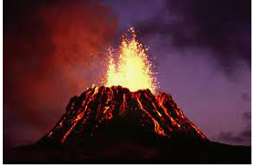
Our final geography topic will be ‘Natural Disasters’ where we will be learning about the structure of the Earth, tectonic plates and about Earthquakes and Volcanoes. We will look at the features, effects and causes of Volcanoes and Earthquakes and learn about natural disasters in the world today. We will discuss how earthquakes and volcanic eruptions have affected people and places over time. We will also look at tsunamis, floods and droughts and how climate change has a part to play in these events.


Art
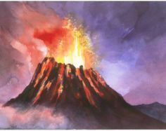
Looking at the artist Margaret Godfrey and producing tissue paper and paint volcano pictures inspired by her work.
How to help your child:
Please ensure your child is in school on time.
Please encourage your child to read every day and record what they have read in their Reading Record. Please remind children to bring their Reading Record into school each FRIDAY.
Please return library books by Wednesday each week and ensure your child has a bag on Wednesday to take home their new library book.
We provide homework each week on a Friday (see Homework Policy below). Please ensure homework is completed and returned the following Wednesday so we can see how your children have been able to apply their learning from the week before and stick in their new homework.
https://canonburyprimaryschool.co.uk/wp-content/uploads/2015/12/Homework-Policy-CPS-2023_12.pdf
Link to the Calculation Policy:
https://canonburyprimaryschool.co.uk/wp-content/uploads/2024/04/Calculation-Policy.pdf

Religious Studies
Question: What matters most to Humanist and Christians?
This term, we will discuss why humans can be both good and bad, making links with Christian ideas.
Learn about Humanist beliefs and lifestyle, identifying some of the similarities and differences with Christianity.
Children will also take part in a debate based on a shared belief between Christians and Humanist: ‘Peace’. Is peace more valuable than money?
Physical Education

Each Thursday, Team Kick Start will focus on team-building games with Year 6.
On a Friday, children will develop their Outdoor Adventurous skills.

Music
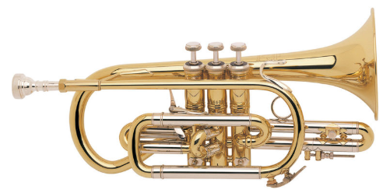
The children will continue to explore their brass instruments every Tuesday.

Design & Technology
This term, our topic is ‘Digital Worlds’
We will use this opportunity to design, make and evaluate a phone case, tablet case or book cover using digital design software, with a link to their time in Canonbury School.

PSHE
We will also be completing secondary transition lessons, to support children with reading a lesson timetable and how to make new friends.
Through RSHE (relationships, sex and health education), children will build on their learning of year 4 to explore changes which take place during puberty, how a baby is made (the human lifecycle) and recognising values in forming relationships

Spanish
Transport
Planning a trip.
Imagine you are really going to your
favourite country. How would you like to travel there?

Weather
Mini-play about the weather and “Feliz Verano” (Happy Summer) song to the tune of Pharell’s ‘Happy’.



Computing
- Online Safety
- Programming – Sensing and coding with Microbits.

