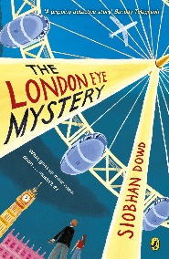
Year 5 Reading
Week 2, Lesson 3
LO: To give and explain the meaning of words in context.
Activity: Use the story to help match each word from the text to its correct definition.
Success Criteria:
- Find each word in green in the text from chapter 2.
- Read the sentence each word is written in.
- Use your understanding of the sentence to match each word to its definition.

mitre
‘The spit of…’
AWOL
Skiving
Edible
Ruffle
Coincidence
Absent without leave
A headdress worn by bishops
To mess up
Accident
Eatable
Exactly like
Not going to school

Activity 2
Write each word in green into a made up sentence. You can challenge yourself further by trying to fit more than one word in green into a sentence.
Example: As I ruffle my dog’s ears, I notice an edible chocolate coin underneath the three-seater sofa. ‘Mmm… surely this is no coincidence’ I think to myself.

