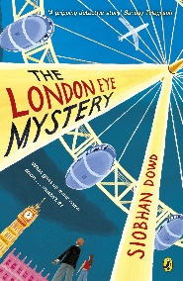
Year 5 Reading
Lesson 1
LO: To read for pleasure.
Success Criteria:
- Read chapter 1 of your guided reading book: The London Eye Mystery.
- Write bullet-pointed notes in your exercise book about the key characters and main events that take place.

Example
- Ted’s favourite thing to do is to fly the London Eye.
- Kat thinks London looks like a toy-town and the cars like abacus beads.
- Salim was taken to the London Eye because he has never been before.

